**A Validated Approach to Simplify the Estimation of the Probability of Creep-Fatigue Crack Initiation for Potential Design Code Implementation**

Saeed Zare Chavoshi1,2,*, Rick Bradford2,3, Julian Booker2

*1Department of Materials, University of Oxford, Parks Road, Oxford OX1 3PH, UK*

*2Department of Mechanical Engineering, University of Bristol, Bristol BS8 1TR, UK*

*3EDF Energy, Barnett Way, Barnwood, Gloucester, GL4 3RS, UK*

*\*Corresponding author: saeed.zarechavoshi@materials.ox.ac.uk*

**Abstract**

This paper provides a possible approach for incorporating probabilistic structural integrity assessment which is sufficiently simple to encourage its adoption by design engineers. The approach, called “Three-Term Reference Damage Model (3T-RDM)”, is highly desirable to provide an intermediate level of assessment which provides most of the benefits of the probabilistic approach without the drawbacks of requiring specialist analytical skills and lengthy computer runs. The suggested 3T-RDM approach is developed in the context of a particular benchmark problem and a proposed Design Chart where the probability of crack initiation by creep-fatigue in a widely used material in nuclear plants, namely 316H austenitic stainless steel, is estimated based on R5V2/3 high temperature procedure. However, the 3T-RDM is not restricted to a particular failure mechanism, i.e., fracture, creep rupture, creep-fatigue crack initiation and growth are all within its scope, and non-metallic materials may also be addressed. To further validate the accuracy and generality of the proposed 3T-RDM and Design Chart, deterministic and Monte Carlo probabilistic structural integrity assessments are conducted for three nuclear plant case-studies and the results are superimposed on the Design Chart obtained from the benchmark problem. The analysis indicates an excellent consistency between the results, justifying the adoption of the 3T-RDM for improved utility and successful application of probabilistic assessment for nuclear sector.

**Keywords:** Probabilistic assessment, Reference damage, Creep-fatigue, Design Chart.

1. **Introduction**

The traditional approach to structural integrity assessments is deterministic. For the purposes of underwriting nuclear safety, adequate conservatism can be ensured in deterministic assessments by using suitable input assumptions in which at least some variables take bounding values, however, the combined likelihood of which is not quantified. The degree of conservatism in such safety related assessments can be such that, whilst entirely appropriate for ensuring safety, they give no realistic picture of plant lifetimes. On the other hand, structural integrity assessments of nuclear plants are subject to considerable uncertainty due to many factors including loading, operating conditions, assessment methodology and materials’ property data. Consequently, it is desirable to carry out such assessments in a probabilistic manner, to determine the probability or frequency of failure. Such an approach is virtually obligatory in cases where cracks are known, or conceded, to initiate in bounding components since bounding deterministic assessments cease to be helpful at that point. Accordingly, probabilistic assessments of crack initiation and growth have become increasingly desirable in the nuclear sector to underwrite the lives of boiler and reactor internal components such as the through-life management strategies. One of the purposes of a probabilistic treatment is to predict future leak and remediation rates, and hence the likely commercial impact and the degree of challenge to the safety envelope.

The probabilistic assessment is commonly performed by Monte Carlo (MC) simulation, which is based on random sampling. Fundamentally, it consists of running a deterministic assessment a very large number of times with different combinations of randomly sampled input data in order to build a statistical picture of the output quantities [1]. The method has a very wide range of applicability, engineering applications being only one. The method is particularly appropriate when there are a large number of independent variables which can influence the outcome. The MC method is being used increasingly in structural integrity of nuclear plants. For instance, Bradford and Holt [2, 3] applied MC probabilistic simulation to a large population of nominally identical components in an Advanced Gas-cooled Reactor (AGR) boiler operating in the creep regime and showed that the probabilistic approach could provide a better quantitative guide to the commercial threat than traditional deterministic methodologies based on bounding data. In particular, probabilistic assessments could identify the parameters which most significantly influence plant life. Zentuti *et al.* [4-7] presented a probabilistic assessment methodology and subsequently conducted probabilistic assessment for an AGR tubeplate component in the creep-fatigue crack initiation regime to demonstrate the utilities of implementing a probabilistic framework. Qian and co-authors [8, 9] employed MC probabilistic methodology with Nataf transformation as well as the Fracture Analysis of Vessels Oak Ridge (FAVOR) computer code, developed by Oak Ridge National Laboratory (ORNL), to analyse the crack initiation and leak-before-break (LBB) behaviour of reactor pressure vessel (RPV). In the same way, Chen et al. [10] applied the FAVOR code to calculate the probabilities of conditional initiation/cleavage frequency of a RPV beltline region subjected to pressurized thermal shock events. Nagai et al. [11] developed a probabilistic fracture mechanics (PFM) analysis code in order to rationally evaluate the failure probability of pipes, containing circumferential crack on the inner surface, in the primary loop recirculation piping in Japanese boiling water reactor (BWR) plants. Hojo and co-workers [12] developed a PFM framework based on the Japan Society of Mechanical Engineers (JSME) rules so as to assess the leak probability time history and failure probability in 40 years operation of different components in Japanese pressurized water reactor (PWR) plants.

In the UK, where AGRs dominate power generation, increased efforts have recently been focussed on plant life extension to help manage future energy generation. This has driven the use of probabilistic approaches in order to increase the confidence in structural integrity assessments through the effective management of uncertainties. Since creep-fatigue crack initiation assessments form an important part of the safety cases for EDF Energy’s AGR power stations, special attention has put to provide advice on probabilistic creep-fatigue assessments, led to R5V2/3 Appendix A15. To further provide guidance on suitability of probabilistic approaches for the design and assessment of nuclear plant components, this paper proposes a method called “Three-Term Reference Damage Model (3T-RDM)” to establish a simplified means of estimating the probability of a crack initiating by creep-fatigue. The suggested approach is developed in the context of a particular benchmark problem to produce a Design Chart, which is a plot of probability of creep-fatigue crack initiation versus 3T-RDM. Probabilistic structural integrity assessments using full MC method are also conducted for three nuclear plant case-studies and subsequently the results are superimposed on the Design Chart so as to achieve a clear picture of the accuracy and generality of the 3T-RDM and its bottlenecks. It is emphasised that the 3T-RDM approach is aimed to provide a simplified means of estimating the initiation probabilities, which is sufficiently simple to encourage its adoption by design engineers. Whilst a fall-back might be full MC analysis, it is highly desirable to provide an intermediate level of assessment which provides most of the benefits of the probabilistic approach without the drawbacks of requiring specialist analytical skills and lengthy computer runs. Yet, its validity and accuracy should be further examined and required refinements for future applications must be identified, which is one of the primary objectives of this study.

The remainder of this paper is organized as follows. In Section 2, the proposed Reference Damage Model is formulated, and Design Chart concept is introduced. In Section 3, MC probabilistic assessment approach and Latin-Hypercube Sampling strategy is described in detail. Hysteresis cycle construction based on R5V2/3 high temperature procedure for calculating creep-fatigue crack initiation damage is presented in Section 4. The benchmark problem and assumed conditions to generate a Design Chart i.e. a plot of initiation probability versus 3T-RDM are explained in Section 5. In Section 6, three EDF nuclear plant case-studies are introduced, which are used to validate the accuracy and generality of the proposed 3T-RDM and Design Chart. In Section 7, the results of the benchmark problem and EDF case-studies are discussed. Section 8 gathers the conclusions and outlines some potential extensions of this work.

1. **Reference Damage and the Design Chart**

The objective is to devise a means of estimating R5V2/3 creep-fatigue crack initiation probabilities which is more rapid than a full MC analysis and hence potentially applicable as the basis of a design code approach. The challenge is to devise a quantity which is more easily calculated than the initiation probability in a full MC analysis, but which can reliably be correlated with it. This quantity could then be used to read the initiation probability off a “Design Chart” of some description.

The proposal for consideration in a design code would be a two-level approach,

* Level 1: Calculate the simplified quantity and estimate the initiation probability from a Design Chart.
* Level 2: Full MC analysis.

The Design Chart based initiation probability would need to be accurate or bounding, but without being overly pessimistic. Different Design Charts would be needed for different generic material types. In this paper, attention is confined to parent 316/316H austenitic stainless steel. The aim would be for the simplified, Level 1, analysis to be sufficient for most applications with Level 2 (full MC) being required only in exceptional cases. The Level 1 Design Chart would be based on generic materials data. If improved results were required due to the use of casts for which superior material properties could be justified and quantified, then a Level 2 analysis would be needed.

In this study, we seek to find a parameter which is computationally less demanding to calculate than a full MC estimate of failure probability, but from which the failure probability can be estimated using a design look-up chart. The parameter that is explored is referred to as “Reference Damage”. Initially it was hoped that the “Reference Damage” could be defined by a single term, i.e., by varying one distributed parameter at a time. However, whilst this approach seemed promising when only the means of distributed variables were changed, it proved insufficient to characterise the failure probabilities which resulted when variances were changed. With the benefit of hindsight, this was to be expected as failures will occur when the failure probability is very small only when more than just one parameter takes an adverse value. After experimenting with changing two variables at a time, it was found that varying three parameters was required to meet the objective of a “Reference Damage” which characterised the failure probability reasonably well. The exact definition of this “Three-Term Reference Damage” is described in the following section. It should be noted that the proposed approach is not restricted to a particular failure mechanism. Potentially, fracture, creep rupture, creep-fatigue crack initiation and creep-fatigue crack growth are all within its scope, and non-metallic materials (e.g., graphite) may also be addressed.

* 1. **The Three-Term Reference Damage Without Correlation**
* Calculate damage based on everything best estimate ($D_{BE}$)
* If $N_{V}$ variables are distributed, consider all combinations of three variables, of which there are $N_{rd}=N_{V}\left(N_{V}-1\right)\left(N_{V}-2\right)/6$.
* For each combination of three variables, carry out a deterministic assessment setting the three variables to their $2σ$ level (plus or minus depending which increases damage; $σ$ is standard deviation), whilst keeping all other variables best estimate, thus giving $N_{rd}$ damage values $D_{i}$ where $i∈\left[1,N_{rd}\right]$. Care must be taken with the signs of the changes from best estimate to ensure that each one increases damage. For example, creep deformation should be increased whereas creep ductility should be decreased. The magnitude of a compressive stress is greater if the error is negative.
* Define the Three-Term Reference Damage as ${D_{Ref}=D}_{BE}+∆D_{rms}$ where, $∆D_{rms}=\sqrt{\frac{\sum_{i=1}^{N_{rd}}{{\left(D_{i}-D_{BE}\right)}^{2}}}{N_{rd}}}$.
  1. **Modification to Include Correlation**

While considering correlation between input parameters, the definition of the three-term reference damage must be modified to accommodate this correlation, as specified below. Note that the definition below is restricted to a single pair of correlated variables, which is sufficient for the analyses.

Suppose variables $X$ and $Y$ are correlated, with Pearson correlation coefficient $C$, which must lie between -1 and +1. In general, the sign is crucial. In the present case it is positive.

**Step (a)**

In the uncorrelated procedure of Section 2.1, the variable $X$ contributes through each damage term $D_{i}$ in which $X$ is one of the three varied parameters. The variable $Y$ may or may not also be one of the varied parameters. There will also be $D_{i}$ involving variation of $Y$ but not of $X$. The three possibilities are,

* $X$ is one of the three terms, $Y$ is not: $D_{i}$ is calculated by setting $X$ at its $2σ$ level and also setting $Y$ at its $2σC$ level.
* $Y$ is one of the three terms, $X$ is not: $D_{i}$ is calculated by setting $X$ at its best estimate value and also setting $Y$ at its $2σ\sqrt{1-C^{2}}$ level.
* $X$ and $Y$ are both in the three terms: $D_{i}$ is calculated by setting $X$ at its $2σ$ level and also setting $Y$ at its $2σ\left(C+\sqrt{1-C^{2}}\right)$ level.

This provides the first estimate of $D_{Ref}$.

**Step (b)**

This is identical to step (a) but with $X$ and $Y$ reversed in the above procedure. This results in a second estimate of $D_{Ref}$. The larger should be used.

Recall that the objective is to find a single parameter in terms of which the failure probability is uniquely determined. This requires that, when plotted against this parameter, the full MC failure probabilities should all fall onto the same unique curve. **Figure 1** illustrates a flowchart representation of the 3T-RDM.



**Figure 1. Flowchart representation of the three-term reference damage model (3T-RDM).**

1. **Monte Carlo Probabilistic Assessment**

The essence of a MC probabilistic assessment is simply to carry out a deterministic assessment many times with different combinations of the distributed parameters. The purpose is to calculate the “failure” (i.e., initiation) probability and hence to provide the target which any proposed estimation technique is required to hit. Basically, a MC probabilistic assessment approximates the probability distribution of an output parameter based on the repeated computations of the performance function using randomly generated combinations of the input variables, with the samples going into these randomly generated combinations being sampled from the associated PDFs or possibly discreet data. The performance function is defined by the underlying deterministic procedure.

To produce appropriate representations of damage distribution, a suitably large number of MC trials must be computed. This puts a limitation on the applicability of MC for computationally intensive calculations. For such cases a sampling strategy such as Latin-Hypercube Sampling (LHS) [13] can aide in reducing the number of trials needed to produce a representative output PDF. LHS is based on the principle that for each input parameter the samples supplied to MC modelling must have equal probability. In other words, a Latin hypercube is a hypercube in which exactly $N_{b}$ variables cells are “occupied” and such that no two occupied cells share a bin in any variable. If an input parameter distribution is known then samples are determined by dividing the area under the PDF into portions of equal area, which in fact represent equal probabilities of occurrence. The fowling section describes the adopted LHS algorithm in this study.

The MC programme used here is written in Visual Basic and MATLAB, where an LHS algorithm is applied. **Figure 2** illustrates a flowchart representation of the MC probabilistic assessment.

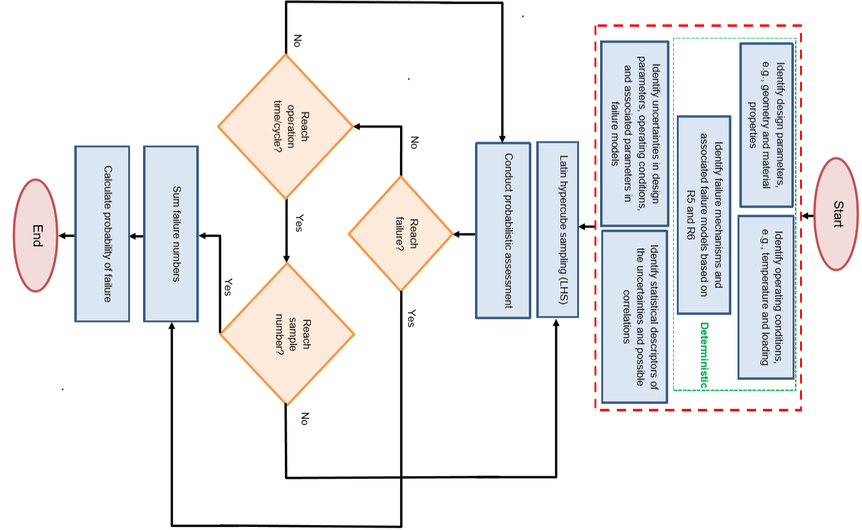

**Figure 2. Flowchart representation of the MC probabilistic assessment.**

* 1. **The Latin-Hypercube Sampling Algorithm**

This section gives sufficient details of the Latin hypercube algorithm in terms of normally distributed variables. This does not prejudice its generality since log-normal distributions are coded as normal distributions of the log-variable. The algorithm is formulated here in terms of dimensionless, normalised error parameters, $z_{i}$. These are the errors in the physical parameters (e.g., temperature, yield stress, etc.) divided by their standard deviation. Hence, $z_{i}$ is the number of standard deviations by which the quantity deviates from its mean (greater than the mean when $z_{i}$ is positive). Hence the relevant normal PDF becomes the standard normal distribution (i.e., with zero mean and unit variance),

$P\left(z\right)=\frac{1}{\sqrt{2π}}\exp\left\{-\frac{z^{2}}{2}\right\}$ (1)

The cumulative probability is,

$P_{cum}\left(z\right)=\int_{-∞}^{z}{P\left(x\right)}dx$ (2)

The algorithm addresses $N_{v}$ distributed variables, $x_{i}$, where $i∈\left[1,N_{v}\right]$. Each parameter takes one of $N_{b}$ possible values, each of which is defined by the mean of the parameter and the value taken by its error variable, $z_{i}$, for the particular random sample in question. Thus,

$x_{i}=\left\langle x_{i}\right\rangle +{\left\langle z\right\rangle }_{i}×σ_{i}$ (3)

where $\left\langle x_{i}\right\rangle$ is the mean of $x_{i}$, $σ_{i}$ is the standard deviation of $x_{i}$, and ${\left\langle z\right\rangle }_{i}$ is one of the $N_{b}$ possible values of the dimensionless error parameter, $z_{i}$. This notation refers to the fact that ${\left\langle z\right\rangle }_{i}$ is some mean, or central, value for one of the $N_{b}$‘bins’ into which the parameter space is divided. The bin ranges are as follows,

Ith Bin: $z∈\left[ξ_{I-1},ξ_{I}\right]$ (4)

Capital subscripts such as I will be used to denote bin numbers, to distinguish them from indices representing the variables, $x_{i}$.

Note that the Latin Hypercube methodology constrains the number of bins, $N_{b}$, to be the same for all of the variables $x_{i}$. Moreover, the bins, equation (4), are also the same for all (normally distributed) variables, $x_{i}$.

In Latin hypercube sampling, the bins $z∈\left[ξ_{I-1},ξ_{I}\right]$ are defined so as to represent equal probabilities. Since there are $N_{b}$ bins this probability must be $1/N_{b}$. This means that,

$P_{cum}\left(ξ_{I}\right)-P_{cum}\left(ξ_{I-1}\right)=1/N_{b}$ (5)

The left-most boundary is chosen to be $ξ_{0}=-∞$ so that $P_{cum}\left(ξ_{0}\right)=0$, and hence equation (5) allows all the bins to be found from,

$1≤I≤N_{b}$ $ξ_{I}=P_{cum}^{-1}\left(P_{cum}\left(ξ_{I-1}\right)+\frac{1}{N_{b}}\right)$ (6)

From this it follows that $ξ_{N_{B}}=+∞$, so the entire parameter space from $-∞$ to $+∞$ is spanned by unequal sized bins with equal probabilities. In practice the bin boundaries, equation (6), must be found numerically since there is no closed-form expression for $P_{cum}$ other than its definition as the integral equation (2). Consequently, a finite value for $ξ_{N}$ will necessarily result. It should be checked that this is a sufficiently large number (of standard deviations) to not prejudice the accuracy of the simulation. This may depend upon the precision of the numerical estimate of $P_{cum}$ and its inverse.

For each bin, a representative value of $z$ must be determined. This is taken to be the mean value of $z$ within the bin, i.e.,

Bin I: $\left\langle z_{I}\right\rangle =\frac{\int_{ξ_{I-1}}^{ξ_{I}}{zP\left(z\right)dz}}{\int_{ξ_{I-1}}^{ξ_{I}}{P\left(z\right)dz}}$ (7)

The denominator is just equal to equation (5), whereas the numerator can be evaluated explicitly for a normal distribution, equation (1), to give,

$\left\langle z_{I}\right\rangle =\frac{N_{b}}{\sqrt{2π}}\left(\exp\left\{-\frac{ξ_{I-1}^{2}}{2}\right\}-\exp\left\{-\frac{ξ_{I}^{2}}{2}\right\}\right)$ (8)

Note that the use of equation (8) is particularly important for the first and last bins since it assigns a finite mean $\left\langle z_{I}\right\rangle$ to a bin of theoretically infinite width. The values of $\left\langle z_{I}\right\rangle$ for the first and last bins define the extremes of the sampling, i.e., the minimum and maximum values.

A Latin hypercube is defined as a choice of $N_{b}$ cells none of which share any row/column/rank/…. etc., covering all $N_{v}$ directions. The Latin hypercube algorithm consists of randomly selecting a Latin hypercube and then using all $N_{b}$ trials which the Latin hypercube represents. The advantage of this approach is that it ensures that every bin of every parameter is used in just $N_{b}$ trials (albeit in only a very small sub-set of possible combinations). Note that this means that the number of trials equals the number of bins, $N_{b}$.

The value chosen for $N_{b}$ determines the greatest number of standard deviations away from the mean which is sampled. It is not possible with the Latin hypercube algorithm to sample a large number of standard deviations using only a small number of trials – because the number of trials equals the number of bins, and this would conflict with the requirement for bins of equal probability.

1. **Hysteresis Cycle Construction Based on R5V2/3**

This section describes the main steps required to calculate the creep and fatigue damages for a single assessment point located on a component using the R5V2/3 Appendix A7 procedure [14]. This defines the performance function which maps the inputs onto the desired output, which in this case is the total creep-fatigue damage at the end of a simulated history.

The central part of an initiation assessment to R5V2/3 procedure is the construction of the stress-strain loop known as hysteresis cycle. A single hysteresis cycle is shown in **Figure 3**, with salient points denoted A, B, C, E, F, G, H, J. Point A is the shutdown condition prior to start-up. Point J is the shutdown condition after trip. The cycle does not close because the loading and temperature conditions at A and J may differ. The difference will be greatest when one is a cold shutdown and the other is a hot standby condition. However significant differences will occur between two different hot standby conditions as well.

The hysteresis cycle construction includes the calculation of the start-of-dwell stress and the cyclic strain range, in terms of which the creep damage and fatigue damage respectively are determined. The full algebraic details of the hysteresis cycle construction algorithm adopted here is elaborated in the following. The procedure is:

1. Construct part-cycle ABC using the Neuber rule and the unmodified Ramberg-Osgood equation – hence find point C.
2. Derive the reverse stress datum (absolute cycle positioning, A)
3. Estimate the start-of-dwell stress (C).
4. Use integration of the HTBASS strain rate to calculate the stress relaxation and increment of creep strain, hence find point E (end of dwell).
5. Construct point G. Depending upon the magnitude of the peak trip stress this may involve linear elastic loading from E to G, with F identified with G, or construction of the half-cycle ABCFG using the Neuber rule and the modified Ramberg-Osgood equation.
6. Construct half-cycle GHJ using the Neuber rule and the unmodified Ramberg-Osgood equation – hence define point J.



**Figure 3. Idealised hysteresis loop for the creep-fatigue initiation problem.**

* 1. **Part-Cycle ABC**

The relevant elastic Mises stress range is $Δσ_{i,el}^{SD-NO}$. The unmodified Ramberg-Osgood expression is used to represent the cyclic strain range in terms of the cyclic stress range. The elastic-plastic strain range and stress range are found from the Neuber construction as follows

$Δσ_{i}^{ABC}Δε_{i}^{ABC}=\frac{{\left(Δσ_{i,el}^{SD-NO}\right)}^{2}}{\bar{E}}$,where, $Δε_{i}^{ABC}=\frac{Δσ_{i}^{ABC}}{\bar{E}}+{\left(\frac{Δσ_{i}^{ABC}}{A}\right)}^{1/β}$ (9)

It is noted that equation (1) should formally be constructed with the modified Ramberg-Osgood expression when $σ_{G}>σ_{C}$. However, this simplification is judged reasonable in this case.

The volumetric correction $Δ{\overline{ε}}_{vol}$ is added to the previous estimate of the elastic-plastic strain range. The secant modulus for the volumetric correction is,

$E_{s}=\frac{Δσ_{i}^{ABC}}{Δε_{i}^{ABC}}$ (10)

And the elastic strain term $Δ{\bar{ε}}_{el,r}$ can be identified with $Δσ_{el}^{AC}/\bar{E}$. Hence,

$Δ{\bar{ε}}_{vol}=(K_{ν}-1)Δ{\bar{ε}}_{el,r}$ $K_{ν}=\left(\frac{1+\bar{ν}}{1+ν}\right)\left(\frac{1-ν}{1-\bar{ν}}\right)$ $\bar{ν}=ν\frac{E_{s}}{\bar{E}}+0.5(1-\frac{E_{s}}{\bar{E}})$ (11)

$Δε_{i}^{ABC} → Δε_{i}^{ABC}+Δ{\overline{ε}}_{vol}$ (12)

The stress and strain ranges are then corrected so as to apply for the undressed weldment. The elastic-plastic strain range for the weldment is found from,

$Δε_{i,weld}^{ABC}=WSEF×Δε_{i}^{ABC}$ (13)

The corresponding elastic-plastic stress range for the weldment is then found by solving,

(14)

* 1. **Reverse Stress Datum (Absolute cycle positioning, A)**

The reverse stress datum is defined as the magnitude of the stress at A, i.e., $\left|σ_{A}\right|$. For cycles starting with a HSB condition, set $σ_{i, A}=σ_{(i-1), J}$, i.e., set the stress at point A for this cycle to the stress at point J at which the previous cycle ends, and put $σ_{i}^{rev}={-σ}_{A}$. Genuine hysteresis cycles will have $σ_{i}^{rev}>0$, $σ_{A}<0$ but elastic unloading might possibly produce $σ_{i}^{rev}<0$, $σ_{A}>0$.

For cycles starting with a CSD condition, the reverse stress datum for the ith cycle is given by

If $Δσ_{i,weld}^{ABC}>\sum{{{(K}_{s}S_{y})}_{i}^{reload}}$ then $σ_{i}^{rev}=\frac{Δσ_{i,weld}^{ABC}}{2}+\frac{{{∆(K}_{s}S_{y})}_{i}^{reload}}{2}$ (15)

else $σ_{i}^{rev} ={{(K}_{s}S_{y})}_{(i-1),SD}$

Note that all $K_{s}S_{y}$ values relate to the last shutdown, i.e., point A.

In all cases,

(16)

* 1. **Start-of-Dwell Stress (C)**

The stress, $σ_{C}$, at point C is thus estimated from,

${\tilde{σ}}_{C}=∆σ_{i,weld}^{ABC}-σ_{i,weld}^{rev}$ (17)

$σ_{C}=MAX\left\{{\tilde{σ}}_{C},σ_{ref}^{R}\right\}$ (18)

This ensures that the start-of-dwell stress cannot be less than the rupture reference stress, .

* 1. **The Creep Dwell and Creep Damage (CE)**

To estimate the stress relaxation during the creep dwell (portion CE), a time stepping scheme include primary rate subtraction is used to calculate the stress drop and the creep damage. Considering primary rate subtraction ensures that the Mises stress cannot relax below the primary rupture reference stress. Thus, stress relaxation is given by the following equation:

$\frac{Z}{\bar{E}}⋅\frac{d\bar{σ}}{dt}=-\left({\dot{\bar{ε}}}_{c}(ε_{c},{Δε}_{pl},\bar{σ},T)-{\dot{\bar{ε}}}_{c}(ε_{c},{Δε}_{pl},σ_{ref}^{R},T)\right)$ (19)

${Δε}_{pl}$ is the plastic strain accumulated since the end of the preceding creep dwell. Creep strain re-priming should be incorporated in the above equation to consider reverse plasticity and account for partial resetting of primary creep. This is performed by adoption of the zeta-factor formulation.

${\dot{\bar{ε}}}_{c}\left(ε_{c},Δε_{pl},\bar{σ},T\right)={\dot{ε}}_{p,ch}+ζ{\dot{ε}}_{p,rp}+{\dot{ε}}_{s}$ (20)

where, $ζ={10}^{0.552-0.005/Δε_{pl}}$ is the zeta-factor, truncated to a maximum of 1. The value of $Δε_{pl}$ is truncated to be a minimum of 0.01% (equivalent to $ζ={10}^{-50}$) in order to prevent singular behaviour. ${\dot{ε}}_{p,ch}$ and ${\dot{ε}}_{p,rp}$ are the primary creep rate assuming continuous hardening and full primary reset, respectively, whereas ${\dot{ε}}_{s}$ is the secondary creep rate.

For creep deformation a relatively new model has been developed by EDF Energy as part of the High Temperature Behaviour of Austenitic Stainless Steels (HTBASS) project. This is referred to as the HTBASS creep deformation model and is given by [15]

${\dot{ε}}_{c}=\exp\left(-\frac{Q_{p}}{RT}\right){\left( ε_{c}+Dε_{\text{pl}}\right)}^{\left(x_{0}+x_{1}T\right)}{\overline{σ}}^{T^{β}}+C_{0}\exp\left(-\frac{Q_{s}}{RT}\right){\overline{σ}}^{{\left(\frac{T}{T_{n}^{'}}\right)}^{γ}}$ (21)

where the fitted values, to uniaxial data, for the various parameters are outlined in **Table 1**. The strains are in absolute values, stresses in MPa and temperatures in Kelvin. Creep strain, $ε_{c}$, and the stress, $\overline{σ}$, are assumed to be Mises equivalent quantities.

**Table 1. HTBASS best estimates for creep deformation of stainless steel 316H.**

|  |  |
| --- | --- |
| Coefficient | Value |
| Qp | 474024 |
| x0 | -7.23794 |
| x1 | 0.005084 |
|  | 0.261108 |
| log10(C0) | 24.7512 |
| Qs | 773904 |
| T'n | 4194.56 |
|  | -1.28005 |
| D | 9.19634.10-4 |

If the assessed location lies in HAZ material, R5V2/3 Appendix A4, Section A4.6.2.2 calls for the dwell stress to be increased by the ratio of the HAZ to parent cyclic strengths at the relevant cyclic strain range, i.e., by the factor HAZ parent $σ_{∆ε}^{HAZ}/σ_{∆ε}^{parent}$.

If $∆ε_{c}$ is the increment of creep strain which results from integrating (xx) over the dwell, the increment of creep damage is given by,

$∆D_{c}=\frac{∆ε_{c}}{Sε_{f,uni}}$ (22)

where $Sε_{f,uni}$ is the uniaxial ductility factored down for the multiaxial stress state. $S$ is the Spindler fraction which is basically used to consider the effect of triaxial stressing in reducing the effective creep ductility [16].

$S=exp\left\{p(1-\frac{σ_{1}}{\overline{σ}})+q(\frac{1}{2}-\frac{3σ_{H}}{2\overline{σ}})\right\}$ (23)

and where $σ_{1},σ_{H},\overline{σ}$ are respectively the maximum principal stress, the hydrostatic stress, and the Mises stress. Creep ductility values for the material 316H are given in **Table 5**, **Table 7**, and **Table 9**.

Note that $∆D_{c}$ should not be calculated from the stress drop i.e. it is not $Z\left|{∆σ}_{c}\right|/E$. The creep strain to be carried forward to the dwell in the next cycle is updated thus,

$ε_{c}^{carried} → ε_{c}^{carried}+∆ε_{c}$ (24)

For completeness the stress at E is,

(25)

* 1. **Left Half-Cycle ABCEFG**

If $Δσ_{i,el}^{NO-Trip}≤\left|{∆σ}_{c}\right|$, meaning that the increase in stress due to trip, $Δσ_{i,el}^{NO-Trip}$, is less than the stress drop due to creep, $\left|{∆σ}_{c}\right|$, then the trip transient merely involves elastic re-loading from E to G. In this case point C is the peak of the cycle and we put,

$σ_{i}^{for}=σ_{c}$ (26)

The stress at G is thus,

$σ_{G}=σ_{E}+Δσ_{i,el}^{NO-Trip}$ (27)

The total strain range calculated from the left half-cycle ABCEFG is,

$Δε_{i,weld}^{ACG}=Δε_{i,weld}^{ABC}+∆ε_{c}+\frac{Δσ_{i,el}^{NO-Trip}}{\bar{E}}$ (28)

where $Δε_{i,weld}^{ABC}$ follows from equation (13) and includes the WSEF and volumetric strain terms.

If $Δσ_{i,el}^{NO-Trip}>\left|{∆σ}_{c}\right|$, meaning that the increase in stress due to trip, $Δσ_{i,el}^{NO-Trip}$, exceeds the stress drop due to creep, $\left|{∆σ}_{c}\right|$, then the trip transient involves additional plasticity. To calculate G we use the Ramberg-Osgood curve with the adjusted elastic stress range given by,

$Δσ_{i,el}^{ACG}= Δσ_{i,el}^{Trip-SD}-\left|{∆σ}_{c}\right|$ (29)

The Neuber construction to find the elastic-plastic stress at point G, $σ_{i}^{G}$, is the solution to,

$(σ_{i}^{rev}+σ_{G})Δε_{i}^{ACG}=\frac{{\left(Δσ_{i,el}^{ACG}\right)}^{2}}{\bar{E}}$, where, $Δε_{i}^{ACG}=\frac{σ_{i}^{rev}+σ_{G}}{\bar{E}}+{\left(\frac{σ_{i}^{rev}+σ_{G}}{A}\right)}^{1/β}$ (30)

The unmodified Ramberg-Osgood is used here. This is reasonable as the tip-to-tip construction is of interest here, and the modified expression would give incorrect results for an un-symmetrised cycle. Also, the above equation applies in those cases (for HSB cycles) when $σ_{i}^{rev}$ may be negative (but we must find that $σ_{i}^{rev}+σ_{G}>0$).

The volumetric strain range correction, $Δ{\overline{ε}}_{vol}$, is then found following R5V2/3 Section 7.4.2, Equations (7.13-16) and added to the elastic-plastic strain range, giving the parent strain range,

$Δε_{i}^{ACG} → Δε_{i}^{ACG}+Δ{\overline{ε}}_{vol}$ (31)

The weldment/HAZ strain range is found as follows,

$Δε_{i,weld}^{ACG}=WSEF×Δε_{i}^{ACG}$ (32)

The corresponding elastic-plastic stress for the weldment at the trip peak, $σ_{G,weld}$, is then found by solving,

$Δε_{i,weld}^{ACG}=\frac{σ_{i}^{rev}+σ_{G,weld}}{\bar{E}}+{\left(\frac{σ_{i}^{rev}+σ_{G,weld}}{A}\right)}^{1/β}$ (33)

The unmodified Ramberg-Osgood is used here. This is reasonable as the tip-to-tip construction is of interest here, and the modified expression would give incorrect results for an un-symmetrised cycle.

$σ_{G,weld}$ is then re-positioned based on the end of dwell because of the use of the unmodified curve above,

$σ_{G,weld}=(Δσ_{i,weld}^{ACG}-Δσ_{i,weld}^{ABC})+σ_{E}$ (34)

The peak stress of the cycle (the forward stress datum) is thus,

$σ_{i}^{for}=σ_{G,weld}$ (35)

Finally, the strain range is increased by the creep strain,

(36)

* 1. **Half-Cycle GHJ**

The relevant elastic stress range between the trip, point G, and the following shutdown, point J, is $Δσ_{i,el}^{Trip-SD}$. The Neuber construction uses the unmodified Ramberg-Osgood equation since there is no creep in this half-cycle. Hence the elastic-plastic stress range for the parent over GHJ is found by solving,

$Δσ_{i}^{GHJ}Δε_{i}^{GHJ}=\frac{{\left(Δσ_{i,el}^{Trip-SD}\right)}^{2}}{\bar{E}}$, where, $Δε_{i}^{GHJ}=\frac{Δσ_{i}^{GHJ}}{\bar{E}}+{\left(\frac{Δσ_{i}^{GHJ}}{A}\right)}^{1/β}$ (37)

The volumetric strain range correction, $Δ{\overline{ε}}_{vol}$, is then found following R5V2/3 Section 7.4.2, Equations (7.13-16) and the elastic-plastic strain range increased by this amount,

$Δε_{i}^{GHJ} → Δε_{i}^{GHJ}+Δ{\overline{ε}}_{vol}$ (38)

The weldment/HAZ strain range is found as follows,

$Δε_{i,weld}^{GHJ}=WSEF×Δε_{i}^{GHJ}$ (39)

The corresponding elastic-plastic stress for the weldment/HAZ is found by solving,

$Δε_{i,weld}^{GHJ}=\frac{Δσ_{i,weld}^{GHJ}}{\bar{E}}+{\left(\frac{Δσ_{i,weld}^{GHJ}}{A}\right)}^{1/β}$ (40)

The Mises stress at point J is therefore given by,

$σ_{i,weld}^{J}=σ_{i,weld}^{peak}-Δσ_{i,weld}^{GHJ}$ (41)

Noting that the sign of this quantity reflects the true stress state, i.e., it is negative for a compressive state and positive for a tensile state. An adjusted point J stress is defined by,

${\tilde{σ}}_{i,weld}^{J}=MAX\left\{σ_{i,weld}^{J} ,-{{(K}_{s}S_{y})}_{i,SD}\right\}$ (42)

Thus, if equation (25) gives a result which is compressive and greater in magnitude than the ${{(K}_{s}S_{y})}_{i,SD}$, bottom-stop then ${\tilde{σ}}_{i,weld}^{J}$ is set to the bottom stop value, i.e., $-{{(K}_{s}S_{y})}_{i,SD}$, otherwise it is just $σ_{i,weld}^{J}$.

The plastic strain is defined as:

$ε_{epp.SPD}^{GHJ,ABC}={\left(\frac{Δσ_{i-1,weld}^{GHJ}}{A_{i-1}}\right)}^{1/β}+{\left(\frac{Δσ_{i,weld}^{ABC}}{A_{i}}\right)}^{1/β}$ (43)

This is used as input to the zeta_p creep re-priming factor, and is based on the plastic strain from previous unloading cycle, plus the current loading cycle. For simplicity this ignores the contribution of plastic strain on trip (EFG), which is judged to be negligible.

* 1. **Fatigue Strain Range**

The strain range to be used for the assessment of fatigue damage is,

${∆ε}_{i,weld}^{fatigue}=MAX\left\{{∆ε}_{i,weld}^{ACG} ,{∆ε}_{i,weld}^{GHJ}\right\}$ (44)

where ${∆ε}_{i,weld}^{ACG}$ is given by either equation (28) or (36) and ${∆ε}_{i,weld}^{GHJ}$ is given by equation (39).

* 1. **Rupture Reference Stress**

Rupture reference stress is of great importance in Neuber construction as it determines the smallest permitted dwell stress in each cycle, thus, it must be carefully calculated. In this section, the approach for calculating rupture reference stress for each case-study, see Section 6, is introduced.

* + 1. **Case-study I**

The following relation is used to calculate reference stress for each bifurcation:

$σ_{ref}^{2}=\frac{3σ_{Hm}^{2}}{4}+3σ_{Qm}^{2}+{\left\{\frac{σ_{Ab}}{3}+{\left[{\left(\frac{σ_{Ab}}{3}\right)}^{2}+{\left(\frac{σ_{Hm}}{2}-σ_{Am}\right)}^{2}\right]}^{1/2}\right\}}^{2}$ (45)

where subscripts H, A and Q refer to hoop, axial and shear components respectively, and subscripts m and b referring to membrane and bending components.

$σ_{ref}^{R}=\left\{1+\frac{1}{n}\left[χ-1\right]\right\}σ_{ref}$ (46)

$χ=\frac{{\overline{σ}}_{el, max}}{σ_{ref}} →$ $χ=WSEF×\frac{{\overline{σ}}_{el, max}}{σ_{ref}}$ (47)

The peak elastic Mises stress, ${\overline{σ}}_{el, max}$, is based on the membrane plus bending stresses for pressure and system loading at the end of the current dwell, appropriately adjusted by the randomly sampled errors and randomly sampled thickness, and then factored to account for the effect of the weld toe. The WSEF (Weld Strain Enhancement Factor) is also included in the definition of $χ$, to account for the effect of the weldment stress raising effect.

Note that it is judged necessary to vary the system load over time, to correctly evaluate the rupture reference stress in order to limit the amount of creep relaxation in any given cycle over the course of the simulation, rather than using an end-of-life value (which would be non-conservative) or a start of life value (which would be over conservative). Accordingly, individual system stress reduction factors, $f_{SSR}$, for each bifurcation at 200,000 hours operation are derived and a Feltham type equation is used to factor the system stresses over time, $f_{SSR}(t)$, for the calculation of the rupture reference stress relevant to the total time at the end of any given dwell for any given bifurcation.

* + 1. **Case-study II**

The solution for the primary reference stress, $σ_{ref}$, of a straight closed end tube of internal radius $R_{i}$ and external radius $R_{o}$, subject to an internal to external pressure difference $∆P$ is based on hoop collapse, which always occurs before axial collapse for pressure loading alone.

$σ_{ref}=\frac{∆P}{ln\left(\frac{R_{o}}{R_{i}}\right)}$ (48)

$σ_{ref}^{R}=\left\{1+\frac{1}{n}\left[χ-1\right]\right\}σ_{ref}$ (49)

$χ=\frac{{\overline{σ}}_{el, max}}{σ_{ref}}$ (50)

Where ${\overline{σ}}_{el, max}$ is the maximum elastically calculated primary von Mises stress on the section. The maximum primary von Mises stress is estimated from the thick tube elastic stresses at the outer and inner surfaces as follows.

Axial Stress $σ_{a}=\frac{\left(P_{i}R_{i}^{2}-R_{o}^{2}\right)}{\left(R_{o}^{2}-R_{i}^{2}\right)}$ (51)

Outer Axial Stress $σ_{a,o}=SCF×σ_{a}$ (52)

Outer Hoop Stress $σ_{h,o}=SCF×\left(2σ_{a}+P_{o}\right)$ (53)

Outer Radial Stress $σ_{r,o}=-SCF×P_{o}$

Outer Von Mises Stress ${\overline{σ}}_{el, o}=\sqrt{\frac{1}{2}\left[{\left(σ_{h,o}- σ_{a,o}\right)}^{2}+{\left(σ_{h,o}- σ_{r,o}\right)}^{2}+{\left(σ_{a,o}- σ_{r,o}\right)}^{2}\right]}$ (54)

Inner Axial Stress $σ_{a,i}=σ_{a}$ (55)

Inner Hoop Stress $σ_{h,i}=2σ_{a}+P_{i}$ (56)

Inner Radial Stress $σ_{r,i}=-P_{i}$ (57)

Inner Von Mises Stress ${\overline{σ}}_{el, i}=\sqrt{\frac{1}{2}\left[{\left(σ_{h,i}- σ_{a,i}\right)}^{2}+{\left(σ_{h,i}- σ_{r,i}\right)}^{2}+{\left(σ_{a,i}- σ_{r,i}\right)}^{2}\right]}$ (58)

Maximum Von Mises Stress ${\overline{σ}}_{el, max}=MAX \left\{{\overline{σ}}_{el, o},{\overline{σ}}_{el, i}\right\}$ (59)

Where $P_{o}$ and $P_{i}$ are the external (gas) and internal (steam) pressures and SCF is the stress concentration factor (SCF).

* + 1. **Case-study III**

The following relation is used to calculate reference stress for cylindrical geometry:

$σ_{ref}=MAX \left\{\frac{∆P}{ln\left(\frac{R_{o}}{R_{i}}\right)},\sqrt{\frac{3}{4}{\left(\frac{∆P}{ln\left(\frac{R_{o}}{R_{i}}\right)}\right)}^{2}+{\left(\frac{3}{4}\frac{M^{DW}}{\left(R_{o}^{3}-R_{i}^{3}\right)}\right)}^{2}}\right\}$ (60)

$σ_{ref}^{R}=\left\{1+\frac{1}{n}\left[χ-1\right]\right\}σ_{ref}$ (61)

$χ=\frac{{\overline{σ}}_{el, max}}{σ_{ref}}$ (62)

Here $M^{DW}$ is the moment due to deadweight only since the thermal moment is assumed secondary. This reference stress solution assumes that the system axial force due to deadweight is small and can be ignored. ${\overline{σ}}_{el, max}$ is given by the following equations.

Pressure axial membrane $σ_{a}^{P}=\frac{R_{i}^{2}}{\left(R_{o}^{2}-R_{i}^{2}\right)}∆P$ (63)

Pressure hoop membrane $σ_{h}^{P,OD}=\frac{{2R}_{i}^{2}}{\left(R_{o}^{2}-R_{i}^{2}\right)}∆P$ (64)

System global bending $σ_{a,gb}^{sys}=\frac{MR_{o}}{I}$ (65)

where, $I=\frac{π}{4}\left(R_{o}^{4}-R_{i}^{4}\right)$ and $M=M^{DW}+M^{th}$ (66)

Total axial membrane $σ_{a}^{tot} = {σ_{a}^{P}+σ}_{a,gb}^{sys}$ (67)

Nominal Mises stress at OD ${\overline{σ}}_{el}^{OD}=\sqrt{\frac{1}{2}\left[{\left(σ_{a}^{tot}- σ_{h}^{P,OD}\right)}^{2}+{\left(σ_{a}^{tot}\right)}^{2}+{\left(σ_{h}^{P,OD}\right)}^{2}\right]}$ (68)

Strictly the compressive radial stress due to gas pressure should be included in nominal Mises stress equation but this would have only a small effect on the Mises stress.

The assessment location at the section change has radius features which cause substantial stress concentrations. This is taken into account via an appropriate stress concentration factor, SCF, applied to the axial stresses but not to the hoop stress for these locations. Hence the peak elastic stress at the assessment location is,

Maximum Von Mises Stress at OD ${\overline{σ}}_{el}^{max}=\sqrt{\frac{1}{2}\left[{\left({\tilde{σ}}_{a}^{tot}- σ_{h}^{P,OD}\right)}^{2}+{\left({\tilde{σ}}_{a}^{tot}\right)}^{2}+{\left(σ_{h}^{P,OD}\right)}^{2}\right]}$ (69)

where, ${\tilde{σ}}_{a}^{tot}=SCF×σ_{a}^{tot}$ (70)

This is rather a simplification since the SCF applicable to the axial stress can differ between loads, and the hoop stress should also be factored down in the case of pressure loading. However above equations are adequate for our purposes.

1. **Benchmark Problem**

Whilst simplified, the benchmark problem is a typical R5V2/3 assessment. Consider a structure containing a fluid on one side and insulated on the other, as displayed in Figure 4.



**Figure 4. Notional depiction of the benchmark problem.**

The structure is assumed free of load when cold and shutdown (i.e., the elastically calculated stresses would be zero); There may be a stress raising feature on the fluid-side, and this point is to be assessed; In steady operation the temperatures become uniform and there are therefore no steady operating thermal loads (but there will generally be residual stresses due to thermal transients); For simplicity, shutdown conditions are assumed to be achieved without causing significant thermal transient stressing; Start-up involves a (potentially severe) transient temperature gradient, being hotter on the fluid-side, causing transient thermal compressive stress at the assessed location. The peak, elastically calculated, thermal stress components are considered as the principal stresses, which are negative quantities (compressive stresses).

At the time of peak start-up thermal transient stress other stresses are negligible. But as the start-up temperature gradient dies away, as steady operating conditions are approached and the structure becomes uniform in temperature, the primary pressure load increases and reaches its peak as the operating temperature is achieved. The first and second principal, elastically calculated, pressure stresses are positive quantities, i.e., tensile stresses.

The assessment point is on a free surface so the third principal stress is zero at all times. To simplify the problem further, the principal axes under start-up thermal and steady operating pressure loadings are assumed to be aligned. Moreover, the degree of biaxiality is also assumed to be the same for the two loading types. If the transient thermal stress does not cause (compressive) yielding then it has no effect on subsequent creep which occurs simply under the constant primary load (forward creep). However, the thermal transient does contribute to fatigue. This possibility is accommodated by the cycle positioning rules.

Note that an identical R5V2/3 problem would result from considering the stress raiser and assessment point to be on the insulated side of the structure if start-up thermal stresses were negligible but shut-down thermal transient stresses were large. Peak compression (the bottom of the hysteresis cycle) would then occur on trip rather than start-up. The loading in benchmark problem is such as to produce a stress-strain hysteresis loop with a creep dwell at the peak of the cycle. The corresponding hysteresis loop is shown in **Figure 5**. The structural problem is devised to be reasonably representative of real plant cases.

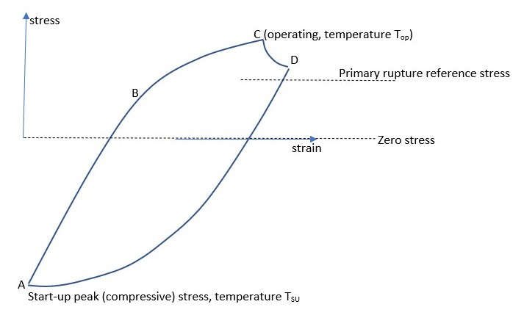

**Figure 5. The Idealised hysteresis loop for the benchmark problem.**

**Table 2** lists the key parameters of the problem, together with the values assigned to them in a notional “base case”. In principle the sensitivity of the failure probability to any of these parameters could be explored. In this work attention has been confined to analysing changes to the subset of parameters listed in **Table 3**, which also indicates the range of each parameter explored here. The parameters in **Table 2** which are not listed in **Table 3** are held constant at their base case values in all runs. The parameters in **Table 3**, to which the sensitivity of the failure probability is to be explored, are the operating temperature, the elastic stress during start-up - which relates to the bottom of the hysteresis loop (point A on **Figure 5**) - and the elastic stress during operation, which relates to the peak of the hysteresis loop (point C on **Figure 5**), together with the standard deviations in these quantities. Note that these three quantities all have two errors associated with them. One is a systematic (or time independent) error, which is the same for all cycles within a given MC trial, i.e., it is sampled once per trial. The other is a random (or time dependent) error which is sampled independently for each cycle. To reduce the number of permutations, the time independent and time dependent standard deviations were equal in all cases run (but they were sampled independently).

In total, 10 distributed variables are considered in the analysis. Normal and lognormal distributions are assumed to statistically represent uncertainties in material properties and loadings, as shown in **Table 4**. For the 3T-RDM, separate runs were first performed to identify the signs of the changes from best estimate to ensure that each one increases damage.

After defining a Base Case, with specified parameter values (i.e., specified means and variances for all variables) a total of 188 MC simulations were run, with up to 400,000 trials each. The simulations differed by changing the distribution parameters for three particularly important variables, namely the primary stress in steady operation, the transient thermal stress during start-up, and the operating temperature. Those three distributions were changed in two ways, by changing their means and by changing their variances.

Two different load cycling regimes were analysed: (i) a “base load” regime which consisted of 300 load cycles with 1000 hour dwells over a total creep-life of 300,000 hours, and, (ii) a “two shifting” regime which consisted of 15,000 load cycles with 20 hour dwells, giving the same total creep-life of 300,000 hours. The latter is more computationally demanding. The probability of a crack initiating by creep-fatigue was determined from these MC simulations (some of which took several days to run).

In reality a component will generally have substantial life remaining after crack initiation, i.e., before cracking propagates through the structural section or causes gross failure. However, crack initiation may be identified with “failure” in the sense of failure to meet a design code requirement if that requirement is avoidance of crack initiation. In that sense we shall refer to “failure probability” in this section.

Where MC simulations produced large numbers of failures (initiations), the failure probability was estimated simply as $N_{f}/N$, where $N$ was the number of equally likely trials and $N_{f}$ the number of simulated failures. However, when $N_{f}$ was small (less than about 30) a damage fitting and extrapolation method was used instead. This permitted failure probabilities as small as ${10}^{-8}$ to be estimated, from simulations that might have produced only one or two, or perhaps no, failures. Over a large number of applications, evidence was obtained to justify that the method is accurate.

Base load cases often analysed 400,000 trials, and this ran in 5 hours or so. However, two-shifting cases did not simulate much more than 100,000 trials as even this took over two days. More often, the two-shifting cases used 30,000 to 60,000 trials. Combined with the damage extrapolation method this proved adequate. Simulations were terminated at fewer trials if the number of failures had exceeded 50.

The number of bins used was between 30,000 and 400,000, and generally not less than 200,000.

75 base-load cases were run, plus 113 two-shifting cases, 188 in all.

**Table 2. Key parameters of benchmark problem and their values in the base case.**

|  |  |
| --- | --- |
| Definition | Base Case Value |
| “Base Load” 300 cycles with 1000 hour dwells  “Two-Shifting” 15,000 cycles with 20 hour dwells |  |
| Operating temperature, mean | 550 oC |
| Operating temperature, systematic error standard deviation | 10 oC |
| Operating temperature, random error standard deviation | 10 oC |
| Coefficient of variation of modified Young’s modulus | 0.05 |
| Standard deviation in (log of) Ramberg-Osgood A parameter | 0.1 |
| Median Z (elastic follow-up) | 3 |
| Standard deviation in log10(Z) | 0.125 |
| Correlation between creep ductility and creep strain rate | 0.6 |
| Mean of start-up max principal elastic thermal transient stress | -300 MPa |
| Systematic error (standard deviation) in start-up max principal stress | 40 MPa |
| Random error (standard deviation) in start-up max principal stress | 40 MPa |
| Mean of max principal elastic primary stress | 90 MPa |
| Systematic error (standard deviation) in max principal elastic primary stress | 15 MPa |
| Random error (standard deviation) in max principal elastic primary stress | 15 MPa |
| Biaxiality ratio | 0.5 |
| Rupture reference stress as fraction of max principal primary stress | 0.5 |

**Table 3. Parameters for the sensitivity analysis of the initiation probability.**

|  |  |
| --- | --- |
| Parameter | Range of Values Explored |
| Cycles/dwell | “Base Load” versus “Two-Shifting” |
| Operating temperature | 400oC to 625oC |
| Systematic and random error for operating temperature | 5oC to 25oC |
| Mean of start-up max principal elastic thermal transient stress | -400 MPa to -50 MPa |
| Systematic and random error for start-up max principal elastic thermal transient stress | 0 to 60 MPa |
| Mean of max principal elastic primary stress | 30 to 90 MPa |
| Systematic and random error for max principal elastic primary stress | 5 to 25 MPa |

**Table 4. The distributed variables and the assumed distributions for the benchmark problem.**

|  |  |  |  |
| --- | --- | --- | --- |
| Distributed variable number | Distributed variable | PDF | Sign in 3T-RDM |
| 1 | Start-up peak elastic stress, max principal | Normal | + |
| 2 | Normal operating peak elastic stress, max principal | Normal | + |
| 3 | Operating temperature | Normal | + |
| 4 | Creep ductility, transition region | Lognormal | - |
| 5 | Creep ductility, lower shelf | Lognormal | - |
| 6 | Elastic follow-up factor, Z | Lognormal | + |
| 7 | HTBASS creep strain rate | Lognormal | + |
| 8 | Fatigue endurance | Lognormal | + |
| 9 | Ramberg-Osgood parameter, A | Lognormal | - |
| 10 | Young 's modulus | Normal | - |

1. **Nuclear plant case-studies**

The boiler superheater bifurcations in nuclear power stations connect the top of the main boiler tubing to the superheater tailpipes. In general, two boiler tube helices are connected together at one bifurcation. A single tailpipe then conveys the steam from the bifurcation to the superheater outlet header. The details of the bifurcations adjacent tubes are shown in **Figure 6**. The bifurcations, the tailpipes and the boiler tubes at the top of the main boilers adjacent to the bifurcations are all composed of 316H austenitic stainless steel.

Three case-studies are intended to demonstrate the implementation of the probabilistic methodology and 3T-RDM approach for creep-fatigue crack initiation assessments of the I) Boiler superheater bifurcations considering carburisation effects; II) Welded tube spacers in secondary superheater platen considering carburisation effects; III) Section change of tubes of boiler superheater bifurcation inlet. The main objective is to generate a plot of initiation probability versus 3T-RDM and compare it with the Design Chart obtained from the benchmark problem. The underlying creep-fatigue crack initiation assessment is based on the R5V2/3 procedure [14] which is summarised in the next section.



**Figure 6. Photograph of superheater bifurcations and adjacent tube straps in a boiler pod.**

* 1. **Case-Study I**

The history of cracking in the superheater bifurcations shows that the crack growth rates at full power align reasonably well with the assumption that the growth mechanism is creep dominated creep-fatigue and this also aligns with the metallurgical evidence regarding crack growth. In addition, examinations show that a thin surface layer of material becomes severely hardened by carburisation. This carburised layer would degrade creep and fatigue properties compared with the parent substrate, thus providing the potential for premature crack initiation. Such carburisation is known to occur in conjunction with certain types of oxidation, and is common in 300 series steels exposed to reactor coolant, but possibly only in a certain temperature range and with a high degree of variability. Thus, it is imperative to utilize carburised material properties while assessing the superheater bifurcations.

In total, the simulation of the life includes approximately 208,668 steady-operation hours. The superheater bifurcations are made of 316H stainless steel; the material properties i.e., elastic, tensile, fatigue and creep properties, the variabilities (or data scatter) of which are considered based on the previous EDF internal reports. The detailed definition of the problem, and description of the variables are summarised in **Table 5**. In total, 14 distributed variables are considered in the analysis. Normal and lognormal distributions are assumed to statistically represent uncertainties in material properties and loadings, as indicated in **Table 6**.

Accordingly, 1 full MC probabilistic assessment as well as 364 deterministic runs are performed to obtain damages from all combinations of the three variables for calculating 3T-RDM value, see Section 2.1.

**Table 5. Key parameters and their values for case-study I.**

|  |  |  |
| --- | --- | --- |
| Definition | Description | |
|  | | |
| Assessment location | 0-degree crotch location of superheater bifurcations 15 (max loaded), 34 (median loaded) and 38 (low loaded) | |
| Cycles | Cold Shutdown | 35 |
| Hot Standby | 10 |
| Total | 385 |
| Operation time | 208,668 hours | |
| Differential pressure stresses | Normal Operation | 12.9 |
| Trip Overpressure | 15.4 |
| Hot Standby | -4.0 |
| Cold Shutdown | 0 |
| 95% CL random error of pressure stresses | 10% | |
| Linearised elastic axial system stress | 124 MPa  52.5 MPa  -2.4 MPa | |
| Standard deviation of Mode I system stress  *Same fractional error is applied to the other components of system stress. | 38MPa | |
| Mean operating temperature | 507 oC | |
| Standard deviation of operating temperature | 12.1 oC | |
| Dwell time | 542 hrs | |
| Median uniaxial creep ductility for carburised material | 1.0% | |
| 98% CI lower bound of uniaxial creep ductility | 0.25% | |
| Parameters in multiaxial Spindler model | p=2.38  q=1.04 | |
| Median Z (elastic follow-up) | 5.0 | |
| Standard deviation | 1.0 | |
| HTBASS creep strain rate scatter in log10(k) | 0.3805 | |
| Mean creep strain re-priming | 0.552 | |
| Standard deviation of creep strain re-priming in log10(zeta_p) | 0.389 | |
| Young’s modulus | Temperature dependent | |
| Standard deviation of Young’s modulus | 6.06 GPa | |
| 0.2% Proof Stress  *considering soft material (0.2% Proof Stress - 39.4 MPa) | Temperature dependent | |
| 95% CL lower bound of 0.2% Proof Stress | Temperature dependent | |
| Rupture reference stress | Considering Miller multiaxial reference stress | |
| Mean thickness | 3.80 and 4.064 mm | |
| Standard deviation of thickness  *a further allowance of 0.05mm is subtracted. | 0.117 mm | |
| Ramberg-Osgood cyclic stress-strain parameter | Temperature dependent | |
| CoV of Ramberg-Osgood cyclic stress-strain parameter | 0.176 | |
| Weld strain enhancement factor | 1.23 | |
| Mean log10(WSEF-1) | -0.638 | |
| Standard deviation in log10(WSEF-1) | 0.299 | |
| Weld endurance reduction | Incubation phase $N_{i}$ is ignored in fatigue crack initiation | |
| Mean weld toe angle | 29° | |
| Standard deviation of weld toe angle | 7° | |
| Depth of the carburised layer | 0.3 mm | |
| Initial defect size | 0.3 mm | |
| Hardening model | Log-linear evolutionary | |

**Table 6. Distributed variables and the assumed distributions for case-study I.**

|  |  |  |  |
| --- | --- | --- | --- |
| Distributed variable number | Distributed variable | PDF | Sign in 3T-RDM |
| 1 | Pressure stress | Normal | + |
| 2 | System stress | Normal | + |
| 3 | Thickness | Normal | - |
| 4 | Operating temperature | Normal | + |
| 5 | Specific uniaxial creep ductility | Lognormal | - |
| 6 | Parent substrate fatigue endurance | Lognormal | - |
| 7 | Weld toe angle in degrees | Truncated normal | + |
| 8 | Elastic follow-up factor, Z | Truncated normal | + |
| 9 | HTBASS creep strain rate | Lognormal | + |
| 10 | Creep strain re-priming, Zeta_p | Lognormal | + |
| 11 | Weldment fatigue endurance (WSEF) | Truncated lognormal | + |
| 12 | Tensile strength (0.2% proof) | Lognormal | - |
| 13 | Ramberg-Osgood parameter, A | Lognormal | - |
| 14 | Young 's modulus | Normal | - |

* 1. **Case-Study II**

A secondary superheater platen consists of a pair of tubes bent into parallel serpentine rows which are joined to a single tailpipe at the top of the secondary superheater via a bifurcation. Many spacers are welded between the rows of tubes to support and stiffen the platen. The tubes and spacers are all of AISI 316H austenitic stainless steel. The secondary superheater tubes in boiler units operate at high pressure and temperature and are also subject to large cyclic system stresses in the vicinity of the welded tube spacers. They have therefore been the subject of extensive and continuing analysis and creep-fatigue component life assessments. The secondary superheater tubes are also subject to external carburisation in service, which lowers their creep ductility increasing creep-fatigue damage estimates.

The simulated history includes 116 loading cycles with varying dwell times. In total, the simulation of the life includes approximately 220,048 steady-operation hours. The detailed definition of the problem, and description of the variables are summarised in **Table 7**. In total, 13 distributed variables are considered in the analysis. Normal and lognormal distributions are assumed to statistically represent uncertainties in material properties and loadings, as indicated in **Table 8**.

Accordingly, 1 full MC probabilistic assessment as well as 286 deterministic runs are performed to obtain damages from all combinations of the three variables for calculating 3T-RDM value, see Section 2.1.

**Table 7. Key parameters and their values for case-study II.**

|  |  |
| --- | --- |
| Definition | Description |
| Assessment location | Outer diameter of welded tube spacers in secondary superheater platen under normal operation without restriction and overfeed |
| Cycles | 116 |
| Dwell time | Variable for different cycles |
| Operation time | 220,048 hours |
| Differential pressure stress at normal operation | 16.54 MPa |
| 95% CL random error of stresses | 25% |
| Mean operating temperature | 541 oC |
| Standard deviation of operating temperature | 6.3 oC |
| Median uniaxial creep ductility for carburised material | 3.05% |
| 98% CI lower bound of uniaxial creep ductility | 0.74% |
| Parameters in multiaxial Spindler model | p=2.38  q=1.04 |
| Median Z (elastic follow-up) | 1.5 |
| Standard deviation of Z | 0.5 |
| HTBASS creep strain rate scatter in log10(k) | 0.3805 |
| Creep strain re-priming | 0.552 |
| Standard deviation of creep strain re-priming in log10(zeta_p) | 0.389 |
| Young’s modulus and its Standard deviation | Temperature dependent |
| 0.2% Proof Stress and its Standard deviation | Temperature dependent |
| Rupture reference stress | Based on hoop collapse |
| Mean wall thickness | 4.1 mm |
| Standard deviation of mean wall thickness | 0.16 mm |
| Metal loss due to corrosion | Time-varying model |
| Ramberg-Osgood cyclic stress-strain parameter | Temperature dependent |
| CoV of Ramberg-Osgood cyclic stress-strain parameter | 0.176 |
| Fatigue endurance and its CoV | Temperature dependent |
| Weld strain enhancement factor | 1.23 |
| Weld endurance reduction | Incubation phase $N_{i}$ is ignored in fatigue crack initiation |
| Mean log10(WSEF-1) | -0.638 |
| Standard deviation in log10(WSEF-1) | 0.299 |
| Stress concentration factor | 1.22 |
| Standard deviation of SCF | 0.17 |
| Depth of the carburised layer | 0.7 mm |
| Initial defect size | 0.4 mm |
| Hardening model | Log-linear evolutionary |
| Softening model | Log long dwell model |

**Table 8. Distributed variables and the assumed distributions for case-study II.**

|  |  |  |  |
| --- | --- | --- | --- |
| Distributed variable number | Distributed variable | PDF | Sign in 3T-RDM |
| 1 | System stress | Normal | + |
| 2 | Operating temperature | Normal | + |
| 3 | Wall thickness | Truncated normal | - |
| 4 | Specific uniaxial creep ductility | Lognormal | - |
| 5 | Fatigue endurance | Lognormal | - |
| 6 | Stress concentration factor | Truncated normal | + |
| 7 | Elastic follow-up factor, Z | Truncated normal | + |
| 8 | HTBASS creep strain rate | Lognormal | + |
| 9 | Creep strain re-priming, Zeta_p | Lognormal | + |
| 10 | Weldment fatigue endurance (WSEF) | Truncated lognormal | + |
| 11 | Tensile strength (0.2% proof) | Lognormal | - |
| 12 | Ramberg-Osgood parameter, A | Lognormal | - |
| 13 | Young 's modulus | Normal | - |

* 1. **Case-Study III**

Boilers comprise a number of cylindrical pods with helically wound steam tubes. At the top of the superheater section, the (finned) tubes are joined to tailpipes via forged bifurcations. The tailpipes then proceed upwards (with flexibility bends) to the superheater outlet tubeplates/headers. Each superheater tube is held by a tube strap upstream of the bifurcation, but the unsupported length from bifurcation to strap varies from tube to tube. The tubes and bifurcations are all of AISI 316H austenitic stainless steel. The superheater tubes operate at high pressure and temperature and are also subject to relatively large cyclic system loading in the vicinity of the bifurcations. Therefore, it is important to justify adequate creep-fatigue life of the bifurcations and adjacent pipework. The highest stresses resulting from the loading are found in the vicinity of the bifurcation to superheater tube welds, section change, and at the tube strap locations. These are therefore the locations for which creep-fatigue crack initiation assessments are performed.

For the specific case-study III, outer surface of the section change of tubes has shown the highest probability of crack initiation, thus, it would be the focus of this study. The simulated history included 216 loading cycles with varying dwell times. In total, the simulation of the life includes approximately 259,047 steady-operation hours. The detailed definition of the problem, and description of the variables are summarised in **Table 9**. In total, 13 distributed variables are considered in the analysis. Normal and lognormal distributions are assumed to statistically represent uncertainties in material properties and loadings, as indicated in **Table 10**.

Accordingly, 1 full MC probabilistic assessment as well as 286 deterministic runs are performed to obtain damages from all combinations of the three variables for calculating 3T-RDM value, see Section 2.1.

**Table 9. Key parameters and their values for case-study III.**

|  |  |
| --- | --- |
| Definition | Description |
| Assessment location | Outer surface of section change of tubes in boiler superheater bifurcation inlet |
| Cycles | 261 |
| Dwell time | Variable for different cycles |
| Operation time | 259,047 hours |
| Differential pressure stress at normal operation | 11.86 MPa |
| Standard deviation of thermal moment | 10 Nm |
| Random error of deadweight moment | 25% |
| Mean operating temperature | 604 oC |
| Standard deviation of operating temperature | 9.4 oC |
| Median uniaxial creep ductility | 10.7% |
| 98% CI lower bound of uniaxial creep ductility | 2.6% |
| Parameters in multiaxial Spindler model | p=2.38  q=1.04 |
| Median Z (elastic follow-up) | 4 |
| Standard deviation of Z | 1 |
| HTBASS creep strain rate scatter in log10(k) | 0.3805 |
| Creep strain re-priming | 0.552 |
| Standard deviation of creep strain re-priming in log10(zeta_p) | 0.389 |
| Young’s modulus and its Standard deviation | Temperature dependent |
| 0.2% Proof Stress and its Standard deviation | Temperature dependent |
| Rupture reference stress | Based on deadweight moment and differential pressure stress |
| Mean wall thickness | 3.582 mm |
| Standard deviation of mean wall thickness | 0.05 mm |
| Metal loss due to 1st chemical clean after 103000 hrs  Metal loss due to 2nd chemical clean after 125000 hrs  Metal loss due to 3rd chemical clean after 162000 hrs | 57 µm  30 µm  30 µm |
| Internal and external metal loss (oxidation, off-load IGA, chemical clean) | Time varying |
| Ramberg-Osgood cyclic stress-strain parameter | Temperature dependent |
| CoV of Ramberg-Osgood cyclic stress-strain parameter | 0.176 |
| Fatigue endurance and its Cov | Temperature dependent |
| Stress concentration factor | 1.97 |
| Standard deviation of SCF | 0.17 |
| Initial defect size | 0.4 mm |
| Hardening model | Log-linear evolutionary |

**Table 10. Distributed variables and the assumed distributions for case-study III.**

|  |  |  |  |
| --- | --- | --- | --- |
| Distributed variable number | Distributed variable | PDF | Sign in 3T-RDM |
| 1 | Deadweight moment | Normal | + |
| 2 | Thermal moment | Normal | + |
| 3 | Operating temperature | Normal | + |
| 4 | Wall thickness | Truncated normal | - |
| 5 | Specific uniaxial creep ductility | Lognormal | - |
| 6 | Fatigue endurance | Lognormal | - |
| 7 | Stress concentration factor | Truncated normal | + |
| 8 | Elastic follow-up factor, Z | Truncated normal | + |
| 9 | HTBASS creep strain rate | Lognormal | + |
| 10 | Creep strain re-priming, Zeta_p | Lognormal | + |
| 11 | Tensile strength (0.2% proof) | Lognormal | - |
| 12 | Ramberg-Osgood parameter, A | Lognormal | - |
| 13 | Young 's modulus | Normal | - |

1. **Results and Discussion**

The performance of the 3T-RDM is illustrated for the benchmark problem in **Figure 7**, **Figure 8**, **Figure 9**, **Figure 10**, and **Figure 11**. The relevant initiation probabilities derived from MC are given together with 3T-RDM values in **Table S1** (base load) and **Table S2** (two-shifting) in Supplementary Material. **Figure 7** plots the initiation probabilities against 3T-RDM for the base-load cases obtained by varying the means of temperature and/or stress whilst keeping their variances fixed at the base case values, where a convincing trend line can be observed. **Figure 8** plots the base-load cases’ probabilities against the 3T-RDM for cases which vary the standard deviations of temperature and stress. In **Figure 8**, the data follow the trend line reasonably well, i.e., the changes in MC initiation probability are tracked quite faithfully by the changes in the 3T-RDM. At this point the 3T-RDM is looking like a credible contender for the sought-for parameter to deploy in a simplified probabilistic design approach. However, it is required to look at how it performs for the two-shifting cases.

**Figure 9** plots, against the 3T-RDM, the initiation probabilities for the two shifting cases obtained by varying the means of temperature and/or stress but keeping standard deviations unchanged, where there is not a unique trend curve but rather temperature dependent trend curves. The continuous green line applies at 550oC and above (to 625oC). However, the trend curve at 475oC (dotted green curve) is substantially different. At temperatures between 475oC and 550oC the trend curve is at an intermediate position (dashed green curve), as is the trend line for temperatures below 475oC, so that the trend line for 400oC and 500oC are similar. **Figure 10** plots all the results for the two-shifting cases, i.e., **Figure 9** plus the cases which vary the standard deviations of temperature or stress. The latter are shown as the red crosses (550oC) or the filled red triangles (475oC). The red crosses and triangles in **Figure 10** fall nicely onto the same trends as the results obtained by varying the means. This is shown more clearly in **Figure 11** which plots only the “red” points in comparison with the (green) trend curves from **Figure 9**.

Hence, in general, the 3T-RDM performs well against base case results (**Figure 7** and **Figure 8**) and reasonably well against the two-shifting cases (**Figure 9**, **Figure 10** and **Figure 11**) although the latter retains some temperature dependence. These results permit a tentative proposal for the Design Chart given in **Figure 12** using the 3T-RDM as a surrogate for full MC simulation. The computational advantage of the reference damage/design chart approach is that (for this realistic problem) only 221 computer runs are required (or 441 runs with correlations) compared with typically 400,000 trials in MC simulations.

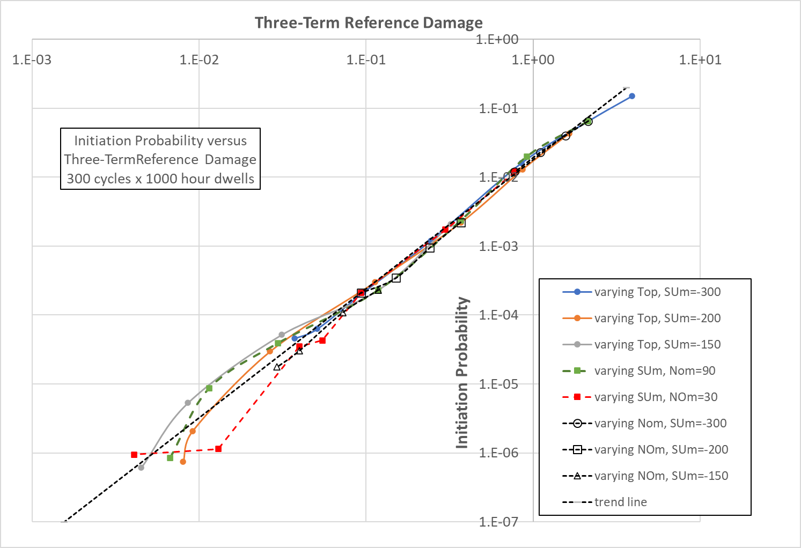

**Figure 7. Base-load cases with base-case variances but differing mean temperatures and stresses.**

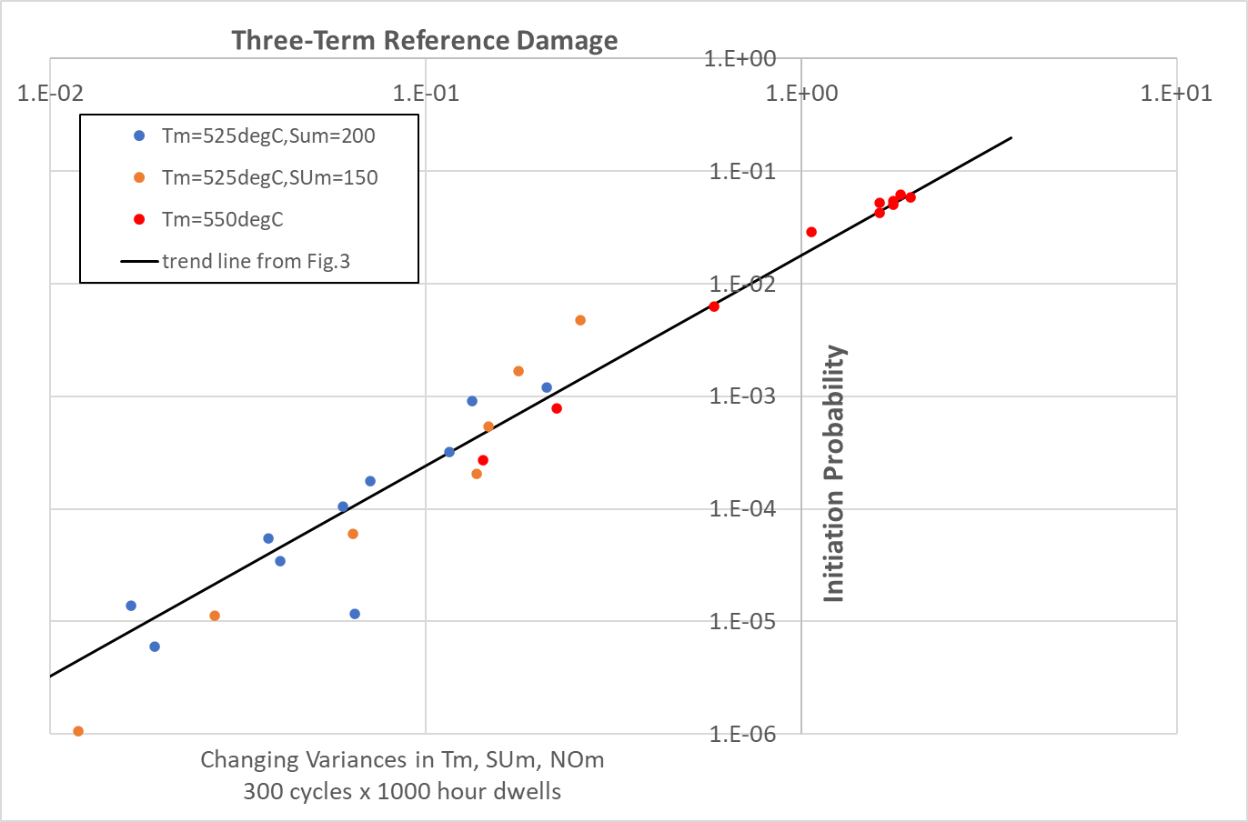

**Figure 8. Base-load cases with a range of variances in temperature and stresses.**

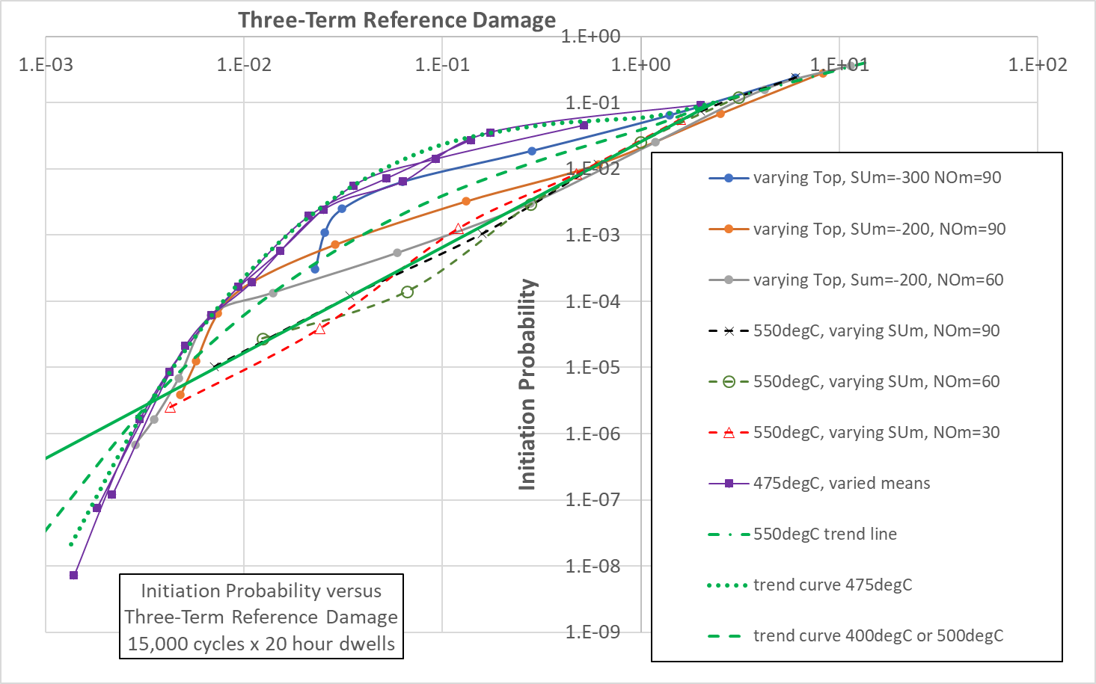

**Figure 9. Two-shifting cases with base-case variances but differing mean temperatures and stresses.**

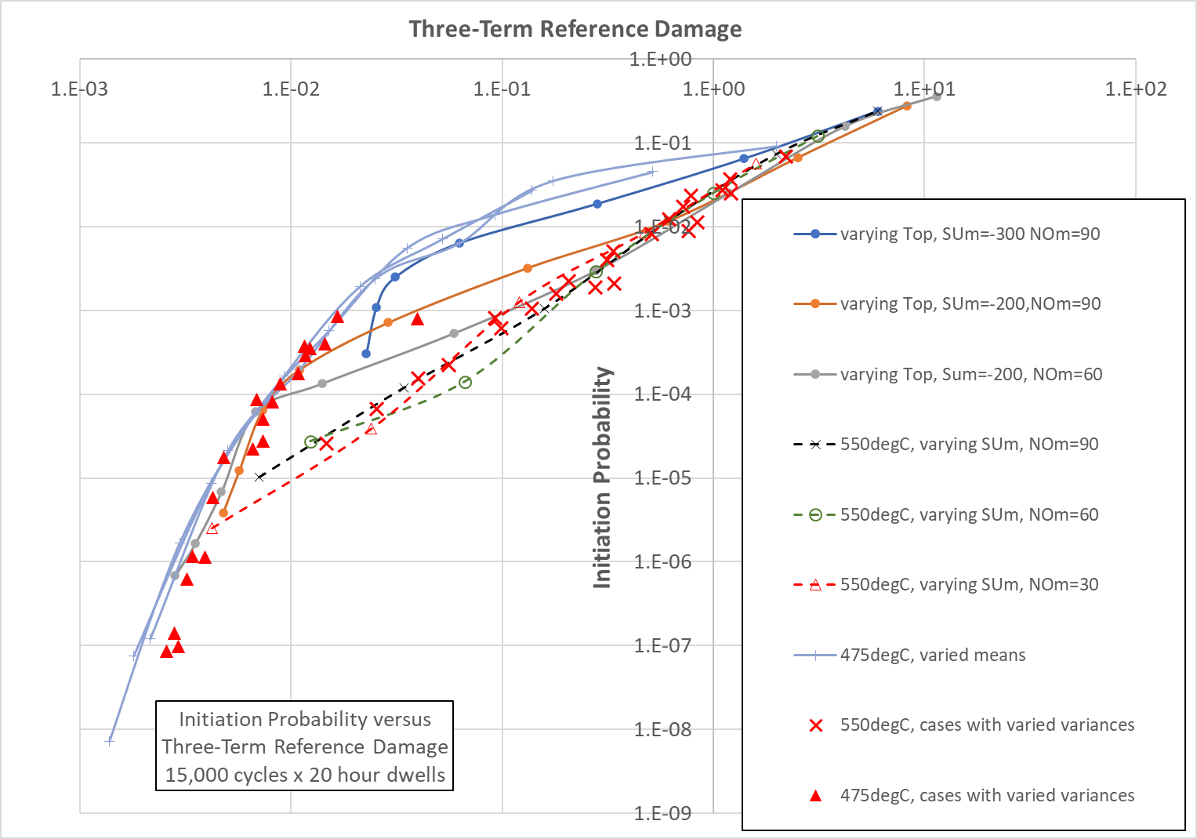

**Figure 10. Two-shifting cases; all data.**

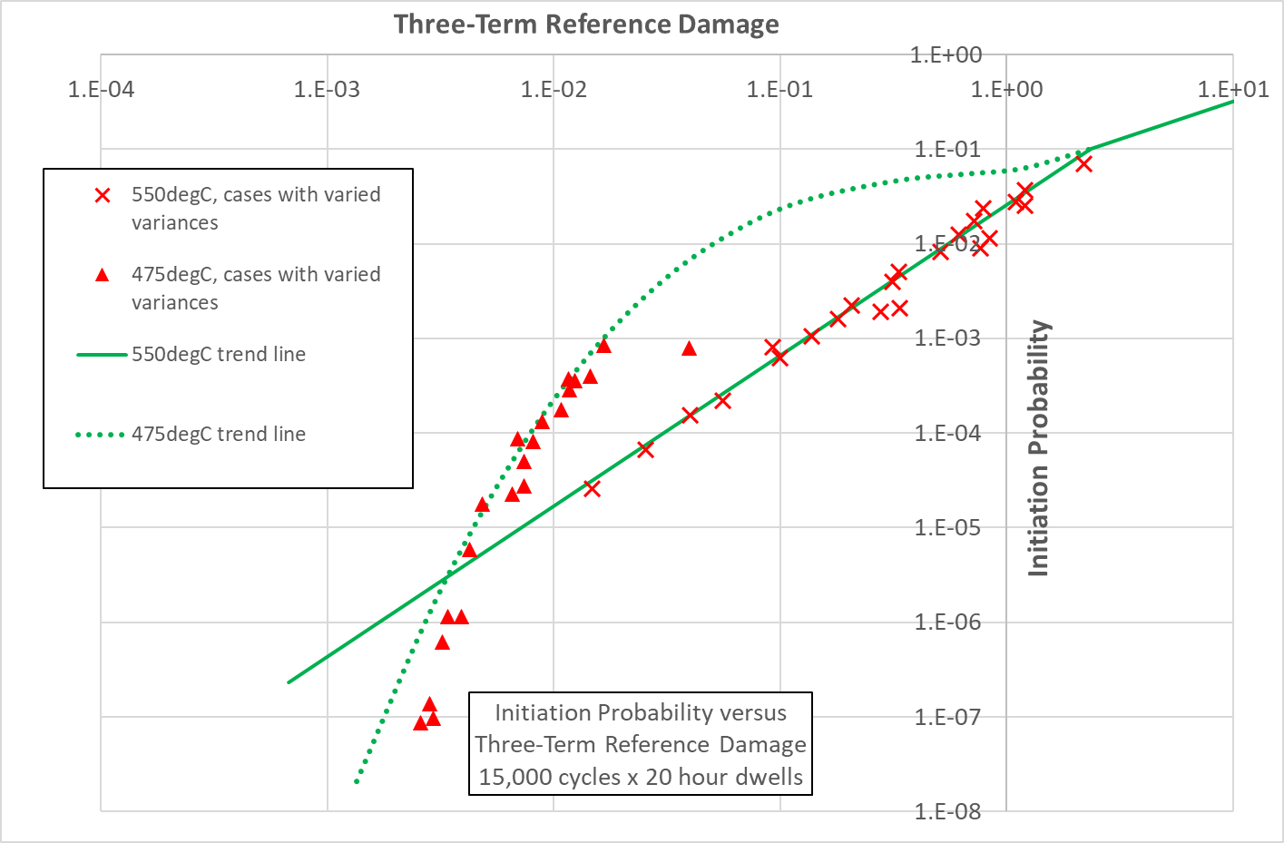

**Figure 11. Two-shifting cases; cases obtained by varying standard deviations compared with the trend curves, Figure 9.**

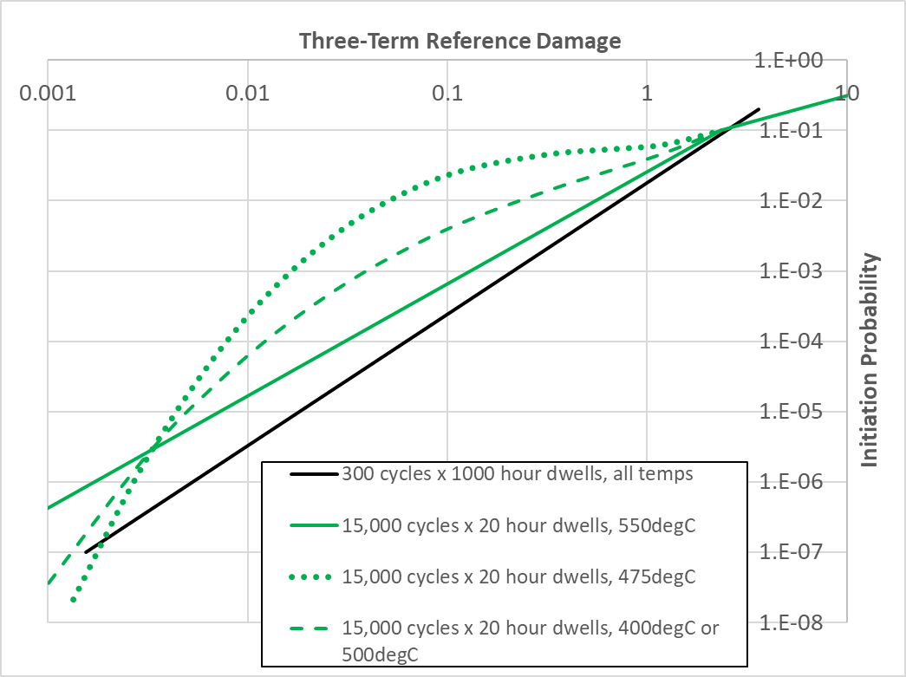

**Figure 12. The Design Chart based on the benchmark problem.**

The initiation probability and damage obtained by probabilistic and deterministic assessments, respectively, as well as the 3T-RDM values for the three EDF case-studies are summarised in **Table 11**. For the 3T-RDM, separate runs were first performed to identify the signs of the changes from best estimate to ensure that each one increases damage. The signs of changes from the best estimates in 3T-RDM are shown in **Table 6**, **Table 8** and **Table 10**. **Tables S3**-**S5** in Supplementary Material demonstrate the predicted damages for all combinations of three variables, which are used to calculate the 3T-RDM values, as described in Section 2.

**Table 11. Initiation probability and damage obtained by probabilistic and deterministic assessments as well as 3T-RDM for the three case-studies.**

|  |  |  |  |  |  |
| --- | --- | --- | --- | --- | --- |
|  | Case-study I | | | Case-study II | Case-study III |
| Assessment location | Bifurcation 15 | Bifurcation 34 | Bifurcation 38 | Welded tube spacers | Section change of tube |
| Initiation probability from MC probabilistic assessment | 0.762 | 0.188 | 0.013 | 0.102 | 0.0372 |
| Damage from deterministic assessment | 6.28513 | 0.115057 | 0.053828 | 0.288283 | 0.011688 |
| 3T-RDM | 126.621 | 6.48532 | 0.26915 | 0.866851 | 0.506862 |

The results of the three case-studies are superimposed on the Design Chart, i.e., plot of creep-fatigue crack initiation probability versus 3T-RDM, obtained from the benchmark problem and displayed in **Figure 13**, where an excellent agreement is observed suggesting the applicability, generality, and accuracy of the proposed 3T-RDM and Design Chart.

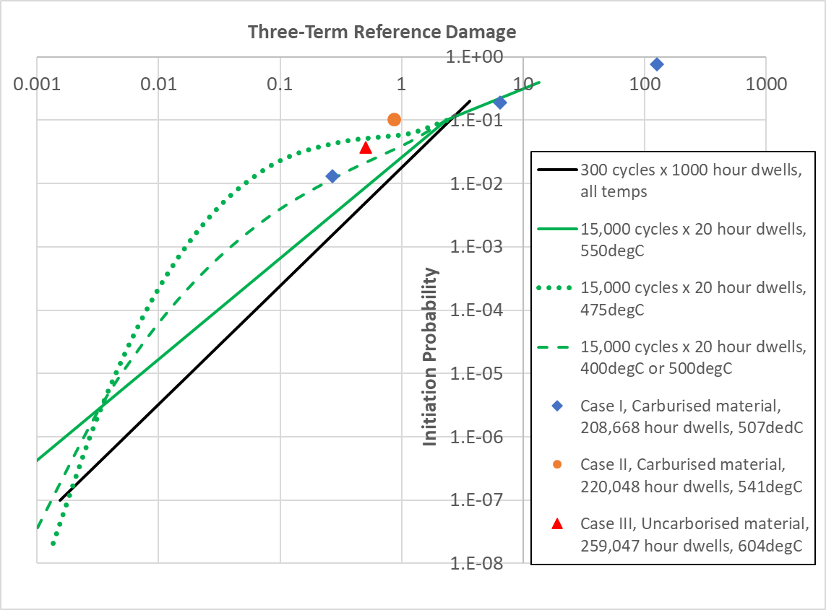

**Figure 13. The Design Chart based on the benchmark problem and superimposed datapoints from the three EDF case-studies.**

**Table 12** provides an overview on pros and cons of full MC probabilistic and 3T-RDM analysis. Implementing the full MC analysis is complex; it requires strong programming skills and statistical knowledge, familiarity with relevant R5V2/3 procedure equations, plant history data and the way of calculating system and pressure stresses for each individual case-study. So, it usually takes a few months to build the first MC probabilistic model. Moreover, MC probabilistic is computationally expensive, i.e. each full MC analysis with the estimated initiation probability of 0.01 to 1 (1000 bins) for one assessment location takes around 5 mins on an 8-core 1.8 GHz laptop. However, when the initiation probability is in the range of 0.001 (10000 bins), the computation time increases exponentially, and each run would take a few hours. But each 3T-RDM run takes 3-4 seconds, yet, the user should keep adjusting the combinations of three variables within the code and perform a few hundred runs, depending on the number of distributed input variable, see Section 2.3.

It should be noted that to generate each data point associated with the case-studies on **Figure 13**, a full MC probabilistic assessment should be conducted to obtain the initiation probability. Then, the deterministic code should be changed to include the combinations of three variables and perform a few hundred deterministic runs to obtain the damage for all three-variable combinations. Accordingly, the 3T-RDM can be calculated, and the initiation probability versus 3T-RDM can be plotted. So, still a good amount of experience and programming skills are needed.

**Table 12. Comparison of the full MC and 3T-RDM analysis.**

|  |  |  |
| --- | --- | --- |
|  | **Full MC analysis** | **3T-RDM** |
| **Complexity of implementation** | High | Low |
| **Statistical knowledge** | High | Low |
| **Time to build model** | Time-consuming, a few months to build the first model | Fast |
| **Computational time** | Relatively slow specially when the initiation probability is low so number of bins are high. | Fast |
| **Experience** | High | Low |

1. **Conclusions**

In summary, a contender as a simplified treatment of probabilistic creep-fatigue crack initiation assessments to R5V2/3 was devised for a benchmark problem. The method is based on a Three-Term Reference Damage together with trend lines which approximate the initiation probability in terms of this reference damage. The trend lines may form the basis of a Design Chart method for new probabilistic design codes in the creep-fatigue regime. However, the proposed Three-Term Reference Damage is not restricted to a particular failure mechanism thus fracture, creep rupture, creep-fatigue crack initiation and creep-fatigue crack growth are all within its purview. and non-metallic materials (e.g., graphite) may also be addressed. Full MC probabilistic assessments and 3T-RDM analysis were subsequently carried out for three representative EDF case-studies, and the results were compared with the Design Chart obtained from the benchmark problem. There was an excellent consistency between the results of proposed Design Chart and and the three case-studies, confirming the applicability, generality, and accuracy of the proposed 3T-RDM and Design Chart.

Due to the generality, computational efficiency and simplicity of the 3T-RDM, it is envisioned that this approach is further employed to consider a broader range of conditions. It is therefore suggested that:

1. More case-studies are studied using both carburised and uncarbonised material properties as well as high temperatures, i.e., above 550 °C.
2. Wider range of temperatures are investigated, and the associated trend lines are produced using the benchmark problem.
3. A systematic exploration of cases with different correlations is required to determine if they plot onto the same trend line.

**Acknowledgement**

This work is a contribution to the EASICS Project, funded by the department of Business, Energy and Industrial Strategy (BEIS). The authors gratefully acknowledge the financial support from the BEIS and EDF High Temperature Centre at the University of Bristol. SZC would like to thank Julian Johns from EDF Energy for his advice and support.

**References**

1. Kroese, D.P., T. Taimre, and Z.I. Botev, *Handbook of monte carlo methods*. Vol. 706. 2013: John Wiley & Sons.

2. Holt, P. and R. Bradford, *Application of probabilistic modelling to the lifetime management of nuclear boilers in the creep regime: Part 1.* International journal of pressure vessels and piping, 2012. **95**: p. 48-55.

3. Bradford, R. and P. Holt, *Application of probabilistic modelling to the lifetime management of nuclear boilers in the creep regime: Part 2.* International Journal of Pressure Vessels and Piping, 2013. **111**: p. 232-245.

4. Zentuti, N., et al., *Probabilistic structural integrity: methodology and case-study in the creep regime.* Materials at High Temperatures, 2020. **37**(2): p. 101-113.

5. Zentuti, N., et al., *A review of probabilistic techniques: towards developing a probabilistic lifetime methodology in the creep regime.* Materials at High Temperatures, 2017. **34**(5-6): p. 333-341.

6. Zentuti, N., et al., *Plant loading uncertainties and their incorporation in probabilistic creep damage assessments.* International Journal of Pressure Vessels and Piping, 2020. **187**: p. 104134.

7. Zentuti, N., et al., *Correlations between creep parameters and application to probabilistic damage assessments.* International Journal of Pressure Vessels and Piping, 2018. **165**: p. 295-305.

8. Qian, G. and M. Niffenegger, *Deterministic and probabilistic analysis of a reactor pressure vessel subjected to pressurized thermal shocks.* Nuclear Engineering and Design, 2014. **273**: p. 381-395.

9. Qian, G., et al., *Probabilistic leak-before-break analysis with correlated input parameters.* Nuclear engineering and design, 2013. **254**: p. 266-271.

10. Chen, M., et al., *The probabilistic structural integrity assessment of reactor pressure vessels under pressurized thermal shock loading.* Nuclear Engineering and Design, 2015. **294**: p. 93-102.

11. Nagai, M., N. Miura, and M. Yamamoto, *Pedestrian: Probabilistic fracture mechanics analysis code based on direct sampling with replacement.* International Journal of Pressure Vessels and Piping, 2018. **167**: p. 52-58.

12. Hojo, K., et al., *Benchmark analyses of probabilistic fracture mechanics for cast stainless steel pipe.* Mechanical Engineering Journal, 2016. **3**(4): p. 16-00083-16-00083.

13. McKay, M.D., R.J. Beckman, and W.J. Conover, *A comparison of three methods for selecting values of input variables in the analysis of output from a computer code.* Technometrics, 2000. **42**(1): p. 55-61.

14. *EDF Energy, R5 Issue 3, Assessment procedure for the high temperature response of structures.* Volume 2/3: Creep-Fatigue Crack Initiation Procedure for Defect-Free Structures.

15. Moffat, A., *Creep Deformation Model for Parent 316H Stainless Steel.* EDF Energy Internal Report, FNC 47354/43103R, 2015.

16. Spindler, M.W., *An Interim Upper Bound Stress Modified Ductility Exhaustion Model for Type 316H.* EDF Energy Internal Report, E/EAN/BBGB/0061/AGR/13, 2013.