Probabilistic creep-fatigue: a plant component case study

N. Zentuti¹, R. Bradford² and J. D. Booker^{2*}

¹Faculty is this complete?, 54 Welbeck Street, Marylebone, London, W1G 9XS, UK
²Solid Mechanics Research Group, Faculty of Engineering, University of Bristol, University Walk, Bristol, BS8 1TR, UK
*j.d.booker@bristol.ac.uk

Summary
This paper presents a probabilistic methodology for assessing the structural integrity of plant components susceptible to creep-fatigue failure and demonstrates the methodology on a plant case study. The methodology is based on the Monte-Carlo approach for estimating failure probabilities, which requires the definition of the underlying procedure for assessing the failure mechanisms of interest, as well as the statistical modelling of the key input parameters. The case-study assesses a plant component (a tubeplate made of 316H stainless steel) for creep-fatigue crack initiation using the R5 Volume 2/3 procedure. This is intended to provide context and demonstrate the utilities of implementing the probabilistic methodology. Building on previous work, four important issues are highlighted: the correlations between dominant input parameters, conducting post-assessment sensitivity analyses, the extrapolation of assessment point probabilities to component-level and, thereafter, population-level estimates. The aim of the research is to promote wider application and acceptance of probabilistics within the international structural integrity community, and identify requirements for further development of the methodology and constituent methods.

Key Words
Probabilistic, creep-fatigue, structural integrity assessment, methodology, statistical characterisation, sensitivity analysis, case study.

Introduction
Conventional calculations in high-temperature structural integrity problems often adhere to well-established codes and procedures and are predominantly deterministic, accounting for uncertainty through the use of conservative factors of safety. Factors of safety are not a quantitative nor consistent measure, usually subjective and commonly based on historic president, and ultimately they do not facilitate a quantitative prediction of the probability of failure. Also, they do not ensure intrinsic reliability, as evidenced by the continued occurrence of failures in-service [1]. The use of probabilistic approaches in the nuclear sector is limited, bespoke and mainly undertaken when traditional deterministic approaches fail to deliver targets due to over conservatism, or fail to explain plant failures. A typical application is for examining uncertainties associated with components in service for life extension of plant [2,3], where the need for formally taking uncertainties into account becomes unavoidable.

Research and case studies focusing on aspects of creep rupture and creep-fatigue crack growth, though creep-fatigue crack initiation, has received more limited attention [2-9]. The literature is concerned with speciﬁc problems and localised method development, while no substantial work has been done on formalising a new general methodology which details each stage of conducting a probabilistic structural integrity calculation. This research builds on the current deterministic approaches for determining the lifetime of plant components as outlined in the R5 Volume 2/3 procedure [10]. This speciﬁc procedure was chosen as a key focus for this work, but the proposed methodology has been presented, wherever possible, as to be divorced from any speciﬁc code or standard. Therefore, it may be implemented within the context of other structural integrity areas (creep-fatigue crack growth, creep rupture, high/low cycle fatigue and fracture mechanics e.g. Leak-Before-Break) and is not exclusive to high-temperature applications.

Figure 1 shows the main statistical and probabilistic methods applicable for creep-fatigue analyses subject to uncertainty. These approaches have been selected based on modelling requirements, data characteristics and computational efficiencies commensurate with the type of problem in creep-fatigue [11-16]. The main methods include: data handling and statistical characterisation of input data using relevant distributions and techniques, with treatment of correlations between selected input data; steady state stress modelling using a surrogate modelling approach coupling Finite Element (FE) analysis, Design of Experiments (DOE), Response Surface Methods (RSM) and Monte Carlo Simulation (MCS), for computational rationalization; and Sensitivity Analysis (SA) using a range of different approaches to gauge the variability contribution of the different input variables and their variances to the output results. These will be overviewed within the context of a case study, with references to further reading for more detail of the methods and approaches used. The methodology is demonstrated through selected results of the life assessment of a plant component from the nuclear sector, a tubeplate, with the objective of predicting the Probability of Initiation (PoI) of cracks due to creep-fatigue damage.

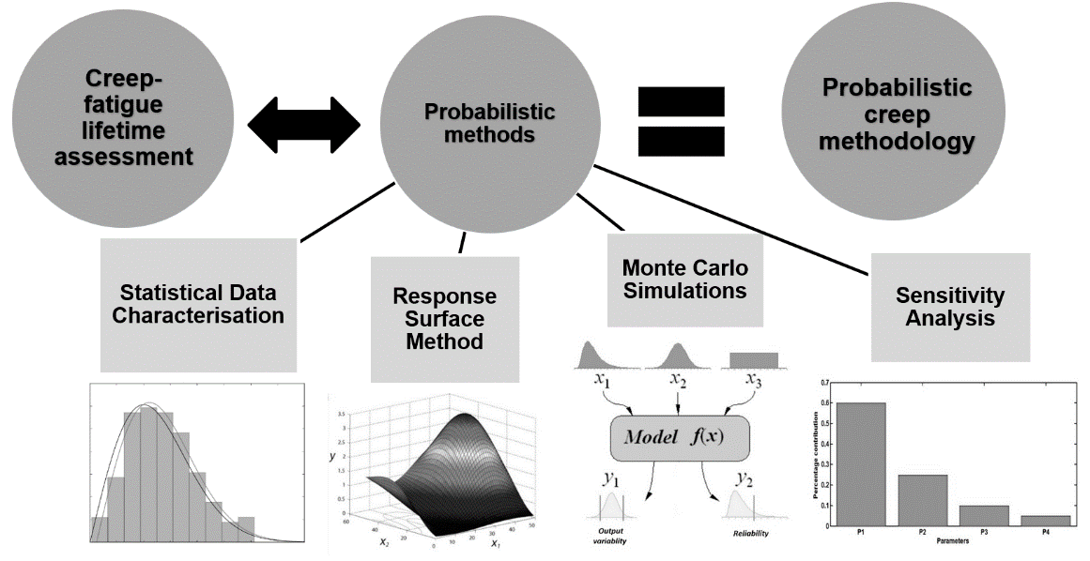
Figure 1 General probabilistic creep-fatigue methodology and methods used.

Case study
Details
A tubeplate is a cylindrical component which has 37 equispaced tubeholes, as shown in the representative FE models in Figure 2. The failure mechanism is creep-fatigue, driven by large thermal transients and over-heating due to tube restrictions. Two separate FE geometries are used for modelling: a sixth model (Figure 2a) for transient loads and a full model (Figure 2b) for steady-state operation. A typical stress-strain hysteresis cycle for a tubehole at its surface is shown schematically in Figure 3.

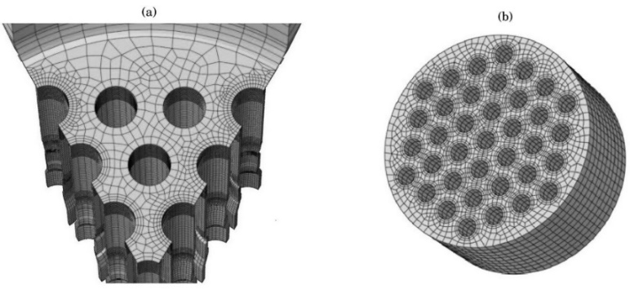
Figure 2 Tube plate component (a) discretised 1/6th FE model (b) full FE model with 37 holes.

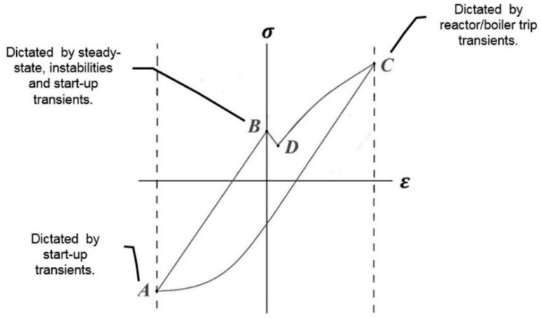
Figure 3 Schematic of a typical stress-strain (σ-ε) hysteresis cycle for a point located on the surface of a tubehole going through RT-SU cycle (RT = Reactor Trip, SU = Start-up).
Material Properties
The tubeplate is forged from 316H stainless steel, with a composition as shown in Table 1 [17]. Creep, fatigue and other mechanical and material properties for this material grade were mainly sourced from [18]. Although data was limited (partitioned sample sizes for defined temperature ranges were as few as 7 samples in some cases), appropriate techniques were used for statistical characterisation were used, as outlined in [11-13].

Table 1 Chemical composition of 316H stainless steel (weight %) [17].

C | Cr | Ni | Mo | Mn | Si | N | Co | S, P, Al, B, Nb, Sn, Ti, V, W, | Fe
0.05 | 17.4 | 11.6 | 2.42 | 1.65 | 0.58 | 0.041 | 0.04 | Trace | Bal.

Table 2 summarises the main material properties input data, units and the statistical distributions the data was best characterising the data, i.e. Normal, Lognormal, Coefficient of Variation (CoV) etc (it also provides the terminology for parameters associated with stress modelling used later). Note, that geometry parameters are not considered as random variables in the case study, simplifying the probabilistic modelling approach for stresses, discussed later.

Making judgements regarding which statistical distributions best fit the available data is a key activity in any probabilistic approach to a problem. It should be approached systematically using procedures comparing a range of distribution types to ascertain the best fitting model. No single distribution type should initially be assumed, say from historical preference. An example of the difference in the statistical modelling of data is shown in Figure 4, where variants of the Lognormal distribution, 2 and 3 parameter, are compared for statistically modelling creep ductility. A 2 parameter model has a zero threshold, whereas the 3 parameter model includes a threshold, and although it is more difficult to find the 3 parameters, it is a superior statistical model for this important creep property modelling the tail ends.

Table 2 Input parameters with statistical characterisation [11-13].
Parameter Description | Units | Distribution | Median (CoV)
Young’s Modulus of Elasticity (E) | GPa | Normal | 158 (0.063)
Proof Stress (S_{y}) | MPa | Normal | 162 (0.26)
Constant in Ramberg-Osgood Expression (A) | MPa | Normal | 1648 (0.127)
Coefficient of Thermal Expansion (α) | 1/C°x10⁻⁶ | Normal | 20 (0.036)
Creep Ductlitliy (ε_{f}) | mm/mm | Lognormal | 1.029 (0.29)
Creep Deformation Rate (έ_{C}) | mm/mm | Lognormal | - (0.381)
Cycles to Fatigue Failure (N_{f}) | Cycles | Lognormal | -
Steady Operation Stress (σ_{SO}) | MPa | Histograms | -
Steady Operation Metal Temperature (T_{SO}) | °C | Histograms | -
Start-up and Reactor Trip Stresses  (σ_{SU} & σ_{RT}) | MPa | Histograms | -256 & 300
Start-up and Reactor Trip Metal Temperatures  (T_{SU} & T_{RT}) | °C | Histograms | 436 & 363

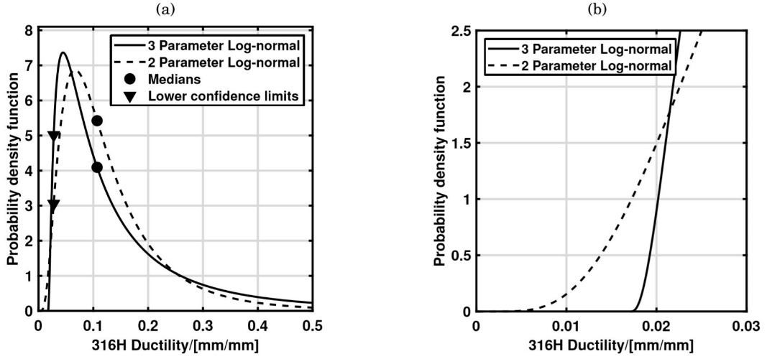
Figure 4 Comparison of 2 and 3 parameter lognormal distributions for modelling creep ductility (ε_{f})
(a) probability density functions (b) zoomed-in view of the tails.

Correlations between input properties must also be considered as they could contribute to the overall uncertainty in the output results from probabilistic calculations. Previous experience suggested a correlation between creep deformation rate and creep ductility existed, but this was not known across working temperature and stress ranges, as well as any possible dependence on creep rate. On investigation of the available data for 316H stainless steel, partitioning sample sizes greater or equal to 7 for statistical relevance, Figure 5 shows the resulting Spearman Correlation Coefficient associated with average, minimum and primary creep rates for 550 and 850 °C. The stress has been normalised [13] for proprietary reasons. The value of the coefficient ranges from 0 to 1 (0 indicating no correlation and 1 indicating perfect correlation). Correlation coefficients from 0.7 to 0.9, are considered strong to very strong relationships, and were included in subsequent probabilistic calculations.
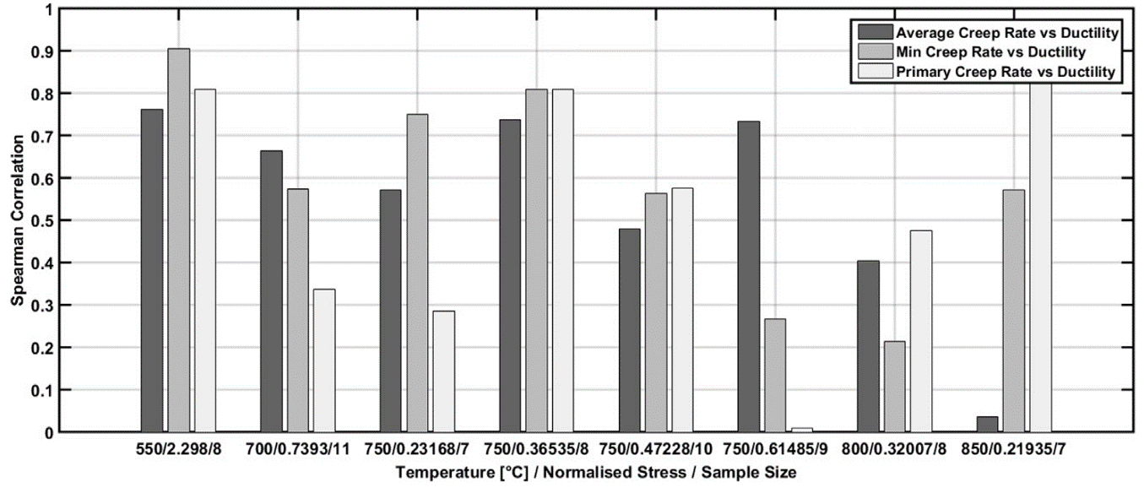

Figure 5 Correlations between three measures of creep deformation rate (έ_{C})and creep ductility (ε_{f}) based on temperature and stress partitioned subsets.

Transient and Steady State Stresses
For a single transient instance, and with the plant data as the starting point, the process for inferring the desired transient conditions is outlined in Figure 6. Transient plant data was available for some start-up and reactor-trip instances. For each transient instance, the data consisted of the following boiler steam measurements: mass flow rate, outlet temperature and outlet pressure. However, a few assumptions had to be made in order to use this data for modelling transients and calculating heat transfer coefficients, including factors associated with measurement location and averaging over all tubeholes. The transient data was then sampled to include key periods of rapid temperature changes. Thereafter the data was ready to be incorporated into the thermal FE model run in in ABAQUS CAE and using the geometry in Figure 2a, yielding all six stress components and correlations drawn between metal temperature and stress for subsequent damage calculations [11,15,16].

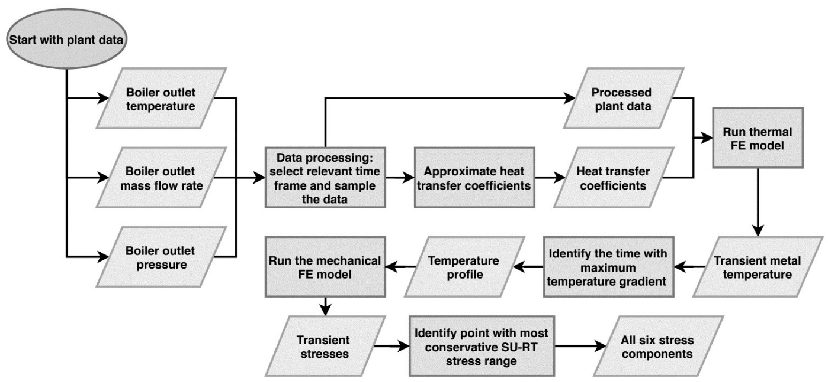

Figure 6 Flowchart showing the various stages involved in identifying the characteristic (peak) stress state during a single transient instance.

The available steady-operation plant data was in the form of hourly recorded thermocouple measurements, the thermocouples being situated above the upper surface of the tubeplate so as to sample the steam exiting from some of the tubeholes. This data spanned approximately 30 years of operation, resulting in a very large data set to process. A discretisation of the temperature history partitioned the data into predefined sets of events based on: maximum steam temperature of any tubehole, and maximum difference between the highest and lowest steam temperatures across the tubeplate (termed the tilt). For the tubeplate component, the limits used to define the temperature ranges for each type of event was obtained from previous work which proposed eight types of steady-operation events [16].

A distinction was made between normal and instability events, with the latter typically producing larger thermal stresses. The raw plant data was processed and an array constructed comprising event types, durations and steam temperatures for the 37 tubeholes. Thereafter, a set of 1300+ history events were run in two FE models; firstly a thermal and then a mechanical model both in ABAQUS CAE, with the FE geometry shown in Figure 2b. Running a complete event in FE required less than 3 minutes, and as such this batch of runs required approximately three days.

Surrogate modelling was proposed for simulating the changing nature of plant loading conditions during steady state operation, thus providing a systematic approach for addressing rather than simplifying complex loading histories. The value of surrogate modelling approaches is in the avoidance of running FE models many times, as required for MCS [15], though an alternative route could have also been chosen using Latin Hypercube Sampling (LHS). Coupling DOE and RSM was concluded as a viable option for surrogate modelling to reduce computational intensity and yield the closed form polynomial equations which could readily incorporate the input parameters as random variables and correlations.

Assessment stresses and temperatures were found to vary significantly across different tubeholes. This prompted the inclusion of individual response surfaces for each assessment location rather than assuming they all endured the same stresses and metal temperatures. This showed that some assessment locations were, naturally, more prone to severe stresses and temperatures and therefore incurred higher creep-fatigue damages.

Damage and Probability of Initiation of Cracks
Initially, deterministic assessments of damage for each tubehole was conducted using median values for all input parameters. This provides focus for later full probabilistic analysis of specific tubeholes. The process of calculating damage is provided in the R5 V2/3 procedure. As can be seen in Figure 7, tubeholes 2, 29 and 37 were predicted to have the most damage across the tubehole component based on this single deterministic assessment. It should be expected that the tubeholes which have larger damage values would also be the most probable to initiate cracks. Therefore, Because input variable variances are comparable between tubeholes, the deterministic damages give good insight as to which tubeholes to prioritise when conducting more time-consuming probabilistic calculations.
I’ve thought it best to weaken the above because it will not be true in other situations that locations with the greatest deterministic damage necessarily have the greatest probability of initiation/failure – namely if variances differ. In fact it’s not completely true here either, as tube 37 does not turn out to be the 3rd highest probability of initiation, but tube 10 (see Figure 9).
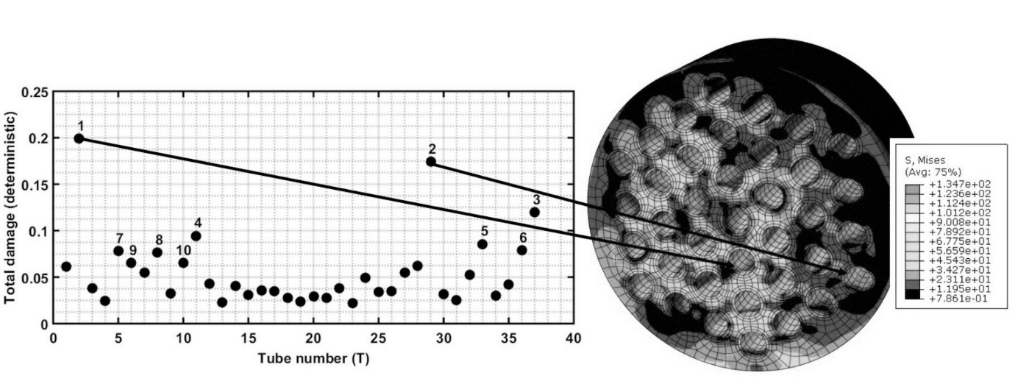
Figure 7 Total damage results of all 37 tubeholes using a deterministic approach and location of holes with highest damage on tube plate ligament (numbers indicate the order of the most damaged tubeholes from highest to lowest total damage).

Focussing on a single tubehole assessment location, probabilistic routines involve running the R5 V2/3 procedure with RSM models for the stress components and simulation of damage predictions using 10⁵ trials in MCS, found from convergence studies [14]. A key probabilistic result is a histogram of the total creep-fatigue damage obtained from the MCS trials conducted, an example of which is shown in Figure 8. Note that the R5 V2/3 procedure predicts crack initiation at a damage of 1. The constituents of the total damage are also presented separately to show that creep dominates the total damage, as indicated by the fatigue damage being relatively small. Thereafter, the PoI was calculated as the fraction of the total number of trials that led to a damage greater than or equal to unity.

The PoI of individual assessment locations can be tracked as the simulated history progresses, which is shown in Figure 9. Logically, for some initial period, no initiations would be expected, which was observed. Figure 9 also shows that once initiations start to occur, an initial jump is predicted. As determined from sensitivity studies shown in [12] for a much simpler assessment case, creep ductility and deformation are two dominant inputs. Therefore, the substantial jump at the start was attributed to trials which had fast creep rates and/or low ductility as these would be expected to initiate first. After these early groups of crack initiations, the subsequent increase in the PoI was gradual which mirrors the progressive accumulation of damage.

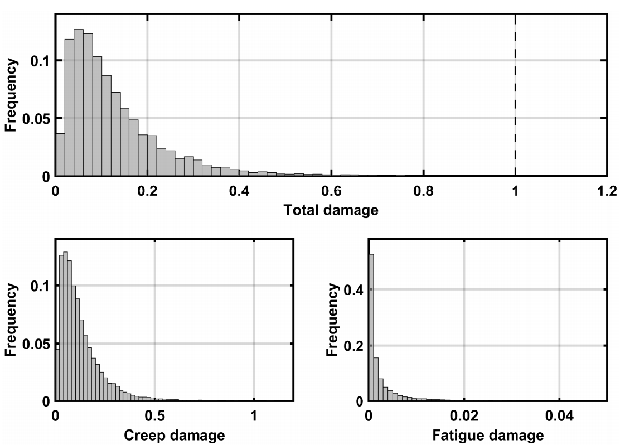
Figure 8 Example histograms of probabilistic damage results for a single assessment location (the criterion for creep-fatigue crack initiation is defined by total damage = 1 shown by the dashed line, which also dictates the PoI)

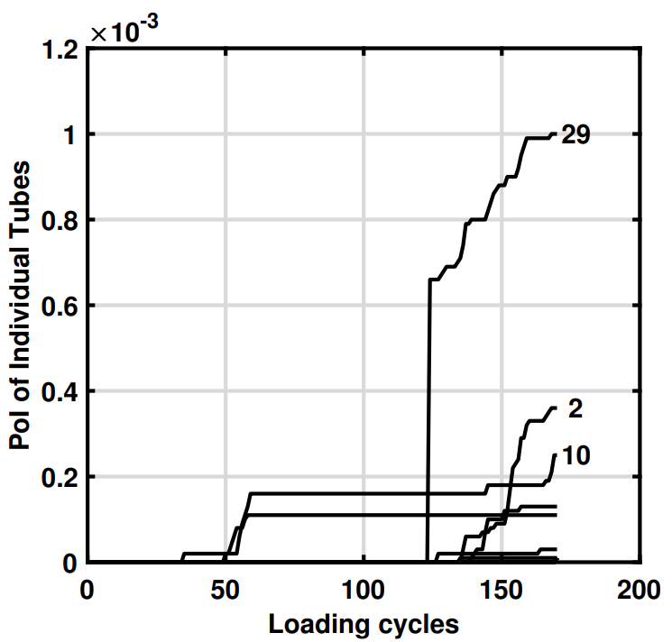
Figure 9 PoI evolution for individual tubeholes during the simulated history (≈170 loading cycles), with each line representing the results from a MCS per tubehole, the three most probable tubeholes to initiation a crack were 29, 2, and 10 labelled.

A number of calculations were conducted to assess the sensitivity of the output damage results towards various inputs. Firstly, sensitivity measures were calculated using four approaches detailed in [12] to assess the dominance of all statistically characterised input data, as shown in Table 2. The easiest of the four approaches is the correlations-based method, as it can be conducted with the results from a single MCS run and a Spearman Correlation Coefficient can be used. This is particularity useful in the development stage of a probabilistic assessment, but when using a small number of MCS trials there is an inherit uncertainty with the SA results using this method. The complete set of SA results is shown in Figure 10 in Pareto chart format, combining three other approaches [12]. Overall, mean contributions from the four different approaches indicates that the input parameters of creep ductility (ε_{f}) and creep deformation rate (έ_{C}) when described as random variables dominate the probabilistic damage results, consistent with the observations made in [12]. Together with variability in the steady state operating stress (σ_{SO}) and Young’s Modulus of Elasticity (E), these four parameters represent a 70% contribution to damage expected in the probabilistic predictions, with the remaining nine parameters combined effect being 30%. Do these last two sentences really mean “contribution to damage” or “contribution to the probability of initiation through the variance in damage”?? I think we need to clarify with Nader.
The obvious outcome from SA is the focus it provides for improvement in data collection (sample size, testes at service conditions etc) and corresponding resources in order to provide increased confidence in predictions in the future. If used in a design setting, it would provide rational focus on where improvements in materials or operating conditions would provide greatest benefit.

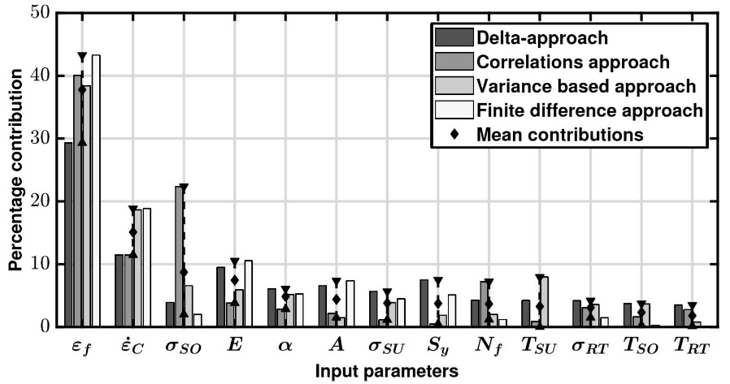
Figure 10 Sensitivity analysis using four different approaches (see Table 2 for input parameters terms).

Component and Population Level Considerations
Based on the methods discussed, the probability of having at least one crack initiation in the whole tubeplate can be estimated from the PoI values for individual tubeholes. The tubeholes which dominate can be identified by counting the number of times each tubehole led to the first crack initiation. For the tubeplate, the percentage number of times that each dominant tubehole led to cracking is shown in Figure 11, which provides a quantitative measure of dominance. Thereafter, PoI of a crack for the whole tubeplate can be calculated using a simple, conservative approach where all assessment locations are assumed completely independent of each other [19]. I’m not sure how much this helps the reader. If one has Fig.10, then one actually has the correct answer.

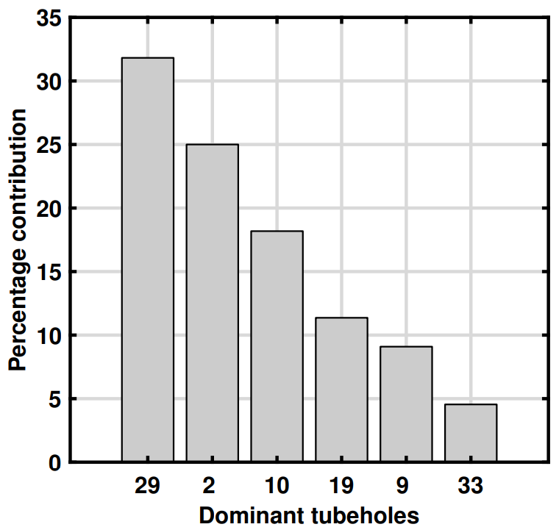
Figure 10 A breakdown of the percentage number of times each of the dominant tubeholes led to the first crack initiation across the whole tubeplate.

Predictions can also be made as to the number of components which have at least one crack initiation given a population of components. All components are assumed to be identical and have the same PoI, which would imply that they all have the same material properties and have experienced the same severity of loading. This is not physically indicative for the real plant case, where some components will be less severely stressed or cycled than others for example. Therefore, calculations based on uncorrelated components will be highly conservative, but the reader interested in this approach is referred to [11].

Conclusion
This paper has provided an overview of a probabilistic methodology applied to a high temperature plant component under complex loading, whose failure mode to crack initiation is quantified by well-known creep-fatigue assessment procedures. Further iterations and adaptations to the methodology are inevitable, driven through collaboration with practitioners of the methodology, to evolve the requirements and to improve utilisation. Through case studies such as the one presented here, numerous challenges in applying a probabilistic and statistical approaches have been explored, which it is assumed would be met in many other structural integrity applications across other sectors, i.e. correct statistical treatment of input data, modelling complex loads, materials characterisation and correlation, etc. The benefit of constructing a probabilistic approach for problems in structural integrity is that probability of failure prediction is possible, avoiding overly conservative (or insufficiently conservative) deterministic thresholds indicating safety or survival of high integrity plant and equipment. In addition, information to the practitioner is available with little extra resource regarding the importance and contribution of key input data as characterised by statistical distributions through sensitivity studies, which focusses further data generation activities and increases confidence in the future probabilistic calculations.

There is added benefit in these efforts, as once a probabilistic methodology has been adopted, different models, correlations and statistical distributions can all be readily explored with confidence for their impact on the objective of the problem, all under the management of uncertainty. For example, the move from a 2 to a ‘better fitting’ 3 parameter Lognormal distribution for creep ductility (as shown in Figure 4) meant up to 40% over-estimates of the PoI across the tubes assessed could be avoided. The inclusions of strong correlations between creep deformation and ductility in the case study produced less scatter and therefore reduced PoI predictions, as compared with ignoring such correlations. Finally, the choice of three available options for creep hardening, as required by the R5 V2/3 procedure, showed that one of the standard models produced larger PoI values compared to the other two, directing future preferences.

It must be remembered that anything which is deterministic can be modelled probabilistically as well; though more time, effort and cost is involved to do so generally. Much more information is needed for a probabilistic approach than for a deterministic one though, self-evidently as shown in the case study here. Moreover, it has sometimes been argued that probabilistic approaches can be used only when all the needed statistical data is available, and it would be misguided to use it otherwise [20], and there are a wide range of well-known implementation barriers inhibiting its use by practitioners [21, 22]. We would argue the opposite, and as illustrated by this case study, that uncertainties do not contra-indicate the application of probabilistics but demand their use: a probabilistic approach is the only approach which is explicit and quantified regarding the structural implications of uncertainties.

Acknowledgments
The authors would like to express their sincere thanks to EDF Energy for supporting this research.

References
- A. D. S. Carter, Mechanical Reliability, 2nd Edition, Macmillan, London, 1986.
- P. J. Holt & R. A. W. Bradford, Application of Probabilistic Modelling to the Lifetime Management of Nuclear Boilers in the Creep Regime: Part 1, International Journal of Pressure Vessels and Piping, 95, 48-55, 2012.
- P. J. Holt & R. A. W. Bradford, Application of Probabilistic Modelling to the Lifetime Management of Nuclear Boilers in the Creep Regime: Part 2, International Journal of Pressure Vessels and Piping, 111-112, pp 232-245, 2013.
- F. Ibisoglu & M. Modarres, Probabilistic Life Models for Steel Structures Subject to Creep-Fatigue Damage, International Journal of Prognostics and Health Management, 6(3), pp 1-12, 2015.
- J. L. Huang et al., Probabilistic Creep Rupture Life Evaluation of T91 Alloy Boiler Superheater Tubes Influenced by Steam-Side Oxidation, Materials and Corrosion, 65(8), pp 786–796, 2014.
- A. Jovanovic et al., ALIAS-HIDA, a Knowledge-based System for Probabilistic & Sensitivity Analysis of Creep & Fatigue Crack Growth in High Temperature Components, OMMI, 3(2), August, 2004.
- J. Wallace et al., Creep Life Uncertainty Assessment of a Gas Turbine Airfoil, Proc. 44th AIAA/ASME/ASCE/AHS/ASC Structures, Structural Dynamics and Materials Conference, American Institute of Aeronautics and Astronautics, Norfolk, VA, April 7-10, 2003.

- B. Dogan et al., Sources of Scatter in Creep/Fatigue Crack Growth Testing and their Impact on Plant Assessment, Welding in the World, 51(7/8), pp 35-46, 2007.
- O. Bielak et al., Risk Based Lifetime Assessment of Piping under Creep-Fatigue Conditions, Transactions of the 17th International Conference on Structural Mechanics in Reactor Technology (SMiRT ‘17) Prague, Czech Republic, Paper # M03-5, 17-22 August, 2003.
- D. W. Dean (Ed.)., R5 An assessment procedure for the high temperature response of structures, R5 Issue 3 Revision 002, EDF Energy, November, 2014.
- N. A. Zentuti, Probabilistic Methodologies in the Creep Regime. PhD Thesis, Department of Mechanical Engineering, University of Bristol, 2019. [research-information.bris.ac.uk/en/theses/probabilistic-methodologies-in-the-creep-regime(33925b50-8d38-474c-b320-70320daa01ef).html, 26 May 2021].
- N. A. Zentuti et al., A Review of Probabilistic Techniques: towards developing a probabilistic lifetime methodology in the creep regime. Materials at High Temperature, 34(5-6), pp 333-341, 2017.
- N. A. Zentuti et al., Correlations between Creep Parameters and Application to Probabilistic Damage Assessments, International Journal of Pressure Vessels and Piping, 165, pp 295-305, 2018.
- N. A. Zentuti et al., Probabilistic structural integrity: methodology and case-study in the creep regime, Materials at High Temperatures, 37(2), pp 101-113, 2020.
- N. A. Zentuti et al., Plant loading uncertainties and their incorporation in probabilistic creep damage assessments, International Journal of Pressure Vessels and Piping, 187, 104134, 2020.
- N. A. Zentuti et al., Management of Complex Loading Histories for Use in Probabilistic Creep-Fatigue Damage Assessments, Proc. ASME 2018 Pressure Vessels & Piping Conference, Prague, Czech Republic. Paper No. PVP2018-84400, 15-20 July, 2020.
- B. Chen et al., Effect of multiaxial stress state and microstructure on creep properties of austenitic stainless steel, Proc. 11th International Conference Engineering Structural Integrity Assessment, January, Manchester, 2011.
- AGR Materials Data Handbook, R66, Issue 6, Rev.010, EDF Energy Nuclear Generation Ltd, November, 2016.
- P. Dillström & F. Nilsson, Probabilistic Fracture Mechanics, in: I. Milne, R. Ritchie & B. Karihaloo (Eds.), Comprehensive Structural Integrity, Pergamon, Oxford, 2003.
- J. E. Shigley & C. R. Mischke, Mechanical Engineering Design, 5th Edition, McGraw-Hill, New York, 1989.
- J. D. Booker et al., A proposal and methodology for the accelerated implementation of probabilistic approaches in the nuclear sector, Proc. 5th International Creep & Fracture Conference (ECCC2021), Edinburgh, 18-21 October, 2021.
- N. A. Zentuti et al., Probabilistic Structural Integrity, FESI Bulletin, FESI Publishing, Preston, 12, pp 16-23, 2018.
- K. V. Bury, Statistical Models in Applied Science, Wiley, New York, 1975.

